A NONPROFIT CHARTER
Live Historic
This is a revolution.
A business case for a public desk that measures any story and hands the measure back to the house.
Join us. Live Historic. Plant trees under whose shade you will never sit. A private opinion does not raise a household.

Vision
Households that remember, and pass it on.
Mission
Measure any story, and hand the measure back to the house.
Core values — the eight measures
Industry · Household · Piety · Courage · Republic · Temperance · Truth · Stewardship
The pine is the mark. The number runs from 0 to 100. The measure stays free. Stories are scored. Blood is not. A party is not. This paper names no person as the mark. Purpose leads.
Prepared as the charter and the business case of the desk. The signature lines are blank until houses adopt it.

How to read this paper
This is the charter of a desk, and the business case for keeping it as a nonprofit commons. It is written so a house, a giver, a guild seat, and a careful reader can find the same answers.
Parts II through VII take the tools of the CUES Advanced Management Program and the eCornell brand-purpose course and answer them for this desk, by name. Professor Chekitan S. Dev (brand purpose, the iceberg, the three-legged stool, the eight characteristics, and the five BRAND pillars). General (Retired) George Casey (vision and strategy in a VUCA world). Brad Treat (the COO mindset). Professor Drew Pascarella (the CFO mindset). Those sessions were built for credit-union leaders. This paper translates them. It does not claim those faculty, Cornell, eCornell, or CUES endorse Live Historic. Their examples — Nike, Apple, Patagonia, Airbnb, Tesla, Hilton, Zappos, and the credit-union tables — stay their examples. The numbers in those tables are not our books.
There is no audited financial statement in this charter, because none is claimed. There is no IRS determination letter. A purpose written in the shape of section 501(c)(3) is a purpose, not an exemption. Exemption is a filing.

Where each question is answered
Question or tool | Where it is answered
Iceberg: brand above the water; strategy, mission, vision, values below | Part II
Three-legged stool: purpose on vision, mission, and values | Part II
CUES Vision? CUES Mission? CUES Core Values? | Part II, stated in one line each
Common themes of favorite vision statements | Part II
Common themes of favorite mission statements | Part II
Common themes of the values examples | Part II
Mind, body, and spirit | Part II
Purpose changes performance; people don't lead people, purpose does | Part II
A purpose platform in the manner of the Hilton slide, for our seats | Part II
Eight characteristics, plus a ninth: commitable | Part III
Professor Dev's five BRAND pillars, scored 1–5 against the description | Part IV
Murray's three principles | Part V
Note to self: one act to emulate, one to avoid | Part V
The sand pile | Part V
VUCA: volatility, uncertainty, complexity, ambiguity — impact and action | Part V
BE and DO; the offensive mindset | Part V
Operating environment: internal, external, competition, relationships | Part V
Two questions, then communicate | Part V
Sustain yourself; three works of a strategic leader | Part V
Direct, organizational, and strategic; the Najaf loop | Part V
COO: two altitudes, Six Sigma, DMAIC, the metric, quality, memory | Part VI
CFO: how the cost is met, what kills, the plan, how to help | Part VII
Every room, the door, and how to move | Part VIII
The ask, and blank lines for adoption | Part IX
The eight, in the desk's own words, and how to read 0–100 | Part X

Part I — The charter
CHARTER OF LIVE HISTORIC
A public desk. A free measure. Houses, not shareholders.

Preamble
A house could once tell what a story was doing before the evening was spent. That knowledge left with the feed. This charter opens a desk that measures any story and hands the measure back to the house. The past is continuous with the present. The work is to pass something on. A private opinion does not raise a household. This is a revolution of attention: not a party, not a product line, not a museum. Join us. Live Historic.

Article I — Name and mark
The name is Live Historic. Live is a verb. Historic is the inheritance, not a costume and not a century used as a mascot. The mark is a pine: a tree planted for shade the planter will not sit under. Beside the name the range runs from 0 to 100. One hundred is a story in full alignment with the eight measures. Zero is a story working against the house.

Article II — Purpose
The purpose is educational and cultural, written in the shape of a public charity: to teach a household to see what a story is doing before the evening is spent. No part of any net receipt may inure to a private person. No gift buys a softer number. This article does not say the Internal Revenue Service has recognized an exemption. Until a determination exists, no one may speak as if it does.
- Vision, the why, the north star: Households that remember, and pass it on.
- Mission, the what and the how, in the present: Measure any story, and hand the measure back to the house.
- Core values, intrinsic, needing no outside permission: Industry, Household, Piety, Courage, Republic, Temperance, Truth, and Stewardship.

Article III — What this is not
- Not a ban, and not a rating issued by the state.
- Not a score of blood, birth, or party. Stories are scored.
- Not an offer of stock, a share of earnings, or a security.
- Not a stream of another maker's picture. The desk links out.
- Not a promise that a service still carries the title.
- Not a private opinion wearing the clothes of an institution.
- Not a claim that a man of 1800 was right about everything. He was often wrong, including on slavery and on a vote that was fenced. The standard is the set of virtues a free household can still use, told in a modern voice. The questions are old.

Article IV — Powers
The desk may publish the rubric; measure a show, a book, an app, a clip, a link, or a thing a house uploads; keep the rooms in Part VIII; receive gifts and optional support from houses; hold a reserve sufficient to keep the door open; speak in public; and do what is required to keep the measure free. It may not sell the household's attention, rent the number to an advertiser, or change a mark to please a sponsor.

Article V — Membership
Members are houses, not shareholders. A house is the people who share an evening and mean to pass something on. Sitting down does not purchase the measure. The guild name, the votes, the seats, and the commonplace may live on the device in that house. They are not, by this charter, an account sold to a stranger. Clearing the browser clears them. A child's full name does not belong on a device shared with people the house does not trust.

Article VI — The measure
Each of the eight measures is marked from 0 to 10. The number a house keeps is the average of those marks, multiplied by ten, and rounded to the nearest whole number. The seal and the band are fixed:
Number | Seal | What the house is told
80–100 | Living Historically | It tells the truth. Sit with it.
65–79 | Worth an evening | Then have the conversation.
45–64 | Watch awake | Or do not watch it.
0–44 | Leave it | It will not make you better.

The same eight apply in every room. A room that needs a ninth virtue is not an improvement. It is a different desk. Depicting a vice is not the same as teaching it. A score is an opinion of the story under this published rubric. It is not a verdict on the people who made it, and not a verdict on the people who already pressed play.

Article VII — Governance
People do not lead people here in place of the purpose. The purpose leads. No person is the mark, and this charter names none. Whoever sits the desk holds a trust with three works: constancy of the eight, patience when a story can be read two ways, and care for the next house rather than the next product. A change to the eight, a sale of attention, or a use of the reserve that would close the door is outside the power of a single evening. Until houses adopt this charter, the lines in Part IX stay blank. Adoption is by the houses then sitting.

Article VIII — Books, reserve, and the free measure
The measure stays free. That is the public good. Optional support from houses, and gifts, may cover hosting, keep a reserve, and improve the desk. Surplus is not a dividend. Surplus means the measure is still free next month and the write-up is better. This charter prints no income statement, no net-interest margin, and no capital ratio, because it will not invent them. The figure that matters, and the only one a steward must be able to say out loud, is how many months the door can stay open if gifts pause. A desk that spends ahead of gifts disappears. A disappeared desk teaches nothing.

Article IX — Dissolution
If the desk is wound up, the ordinary costs of hosting are paid. What remains — the rubric, the mark, and any reserve — goes to another public charity with a similar educational or cultural purpose. If none will take it, it goes as a court of competent jurisdiction directs for a public purpose. It does not go to a person.

Article X — Amendment
The eight may be explained more clearly. They may not be softened to please a sponsor, a fashion, or a fear. An amendment that sells the measure, scores blood, or scores a party is void on its face. Any other amendment is published in the same place as the rubric, so a house can read what changed before it trusts the number.

Article XI — Adoption
This charter is offered to the houses. It is not in force as their act until they adopt it. The lines for that act are in Part IX. They are blank on purpose.

Part II — Purpose: the iceberg and the stool
Professor Dev's session opens with a sentence this charter takes as law: “People don't lead people, purpose leads people.” The tool under that sentence is an iceberg, and a stool with three legs. Both are answered here as Live Historic, not as a classroom hypothetical called CUES.

The iceberg
On the eCornell tool, branding is the small part above the water. Under it, in order, sit strategy, mission, vision, and core values. A house that only sees the pine has not yet seen the desk. A desk that only recites values, and never shows a number, is an iceberg with no tip — invisible, and useless on a Tuesday.
Layer | On this desk
Branding — above the water | The pine. The words Live Historic. The line from 0 to 100. Let's Go. Share. Join us. A card a house can send.
Strategy | Keep the measure free. Score stories, not blood and not a party. One rubric in every room. Grow by houses and by shares of the card, not by a second product. Publish the method. Link out; do not take another maker's picture.
Mission — present, what and how | Measure any story, and hand the measure back to the house. The desired performance is a number the house can use before the evening is spent. The how is eight marks, averaged, times ten.
Vision — future, the why, the north star | Households that remember, and pass it on. Decision rule: if a choice does not help a house remember, or help it pass something on, it is not the work.
Core values — intrinsic | The eight measures. They do not ask a market, a party, or a fashion for permission. They are internally focused: this is how the desk tells the truth.

The stool
Purpose sits on three legs: vision, mission, and values. Pull one out and the stool falls. A vision without the desk is a toast. A mission without the eight is a search box. Values that never leave the people who wrote them are a private opinion, and a private opinion does not raise a household.

CUES Vision?
Households that remember, and pass it on.

That is the vision. It is the why. It is short enough to say at the table. It names a future, not a feature. It gives the desk a test: does this room, this gift, this sentence, help a household remember and pass it on?

Common themes of the vision statements worth keeping
The statements worth keeping share five traits, and this one is built from them. They are short. They name a future, not a catalog. They name a beneficiary a person can picture — here, the household, including people not yet in it. They turn on a verb: remember, and pass. They put a stake in the ground: if the house forgets, the evening is spent on something that will not make it better. Flowery language was taken out on purpose. “Historic” is already a temptation to costume. The vision refuses the costume and keeps the duty.

CUES Mission?
Measure any story, and hand the measure back to the house.

That is the mission. It is present tense. It includes the level of performance the iceberg asks for: the house receives a measure it can use. It says what (measure any story: a show, a book, an app, a clip, a link, an upload) and how (hand it back — not keep it as the desk's private taste).

Common themes of the mission statements worth keeping
They use a verb a newcomer can watch happen. They name the customer, not the vanity of the maker. They show the how without a stack of adjectives. They fit in one breath, so a person under pressure can act on them. Here the customer is the house. The verb is measure. The how is visible: eight marks, one number, put back in the hands of the people who will sit the evening. “Any story” is the stretch. “Hand it back” is the discipline that keeps the stretch from becoming a hoard.

CUES Core Values?
Industry. Household. Piety. Courage. Republic. Temperance. Truth. Stewardship. Each one has an ask, a high, a low, and a line that says what it is not. The full language is in Part X.

Values, on Dev's terms, are intrinsic and internally focused. They are the timeless guiding principles, not a campaign. These eight do not need an external justification. A story is not good on this desk because a crowd liked it. It is good when work, a home, conscience, courage, a duty to neighbors, a limit on appetite, a word that binds, and something left for the people after you are honored — or when the story shows, without glamour, what the absence costs.

Common themes of the values worth keeping
The lists worth keeping are few, named, and behavioral. A person can tell, from the outside, whether the house kept them. They are the same on a good day and a bad day. They are not slogans that change when the quarter changes. Hilton's HILTON list (Hospitality, Integrity, Leadership, Teamwork, Ownership, Now) and the Zappos list of ten are comparison cases from the session. They are not our list, and this charter does not borrow their words to sound staffed. Our values are already a scoring key. That is the behavioral test: a mark of 0 to 10, with a published reason, in every room. A value that cannot survive a low mark is a decoration.

Mind, body, and spirit
The session maps vision to the mind, mission to the body, and values to the spirit. On this desk:
Seat | Building block | Live Historic
Mind | Vision | Households that remember, and pass it on. The picture of a future the desk will not trade away.
Body | Mission | The working desk: name a story, receive eight marks, take the number home. If the body stops, the mind is only a speech.
Spirit | Values | The eight. They do not ask permission. They are why a sponsor cannot buy a different number.

Purpose changes performance
A desk with this purpose does not build a second rating site when the first idea feels slow. It does not add stars beside the eight to look familiar. It does not sell the hour of attention it just helped a house protect. Performance is not a larger shelf. Performance is: did a house get a measure it could use before the evening was spent, did the house pass it on, and did the measure stay free? That is the change of performance purpose is for. A feature that does not serve those three questions is not progress. It is furniture.

A purpose platform, in the manner of the Hilton slide
The session shows a purpose platform that states vision, mission, and values for guests, team members, owners, and communities, in one structure. Live Historic is not a hotel. The same discipline — one platform, four seats, no private version of the values — is applied here.
Seat | What they are owed | What the purpose asks of them
The house (the guest) | A free measure before the evening, in language a parent can say out loud. | Use it. Pass it on. Do not treat a low mark as a verdict on your people.
Whoever sits the desk (the team) | One rubric, psychological safety to give a low mark, no slogan without the desk behind it. | Score the story, not the blood. Publish the reason. Do not soften the eight.
Houses that give (the owners) | A reserve, a free measure, and a plain account of what gifts are for. Not a dividend. Not a vote to change a score. | Give to keep the door open. Do not ask to buy the number.
The town (the community) | Commons, a screening, a month forwarded, desk hours. A standard that is public. | Come as a house. The cynic may speak. He is not the only adult in the room.

Part III — Nine characteristics
The tool lists eight characteristics of a great brand purpose. Vision, mission, and values are three distinct blocks, and each should carry all eight. A later page of the same session adds a ninth, commitable: committed in everything we do. This part grades our three blocks against all nine. A pass means the block meets the characteristic as the tool defines it. Where the stretch could break the desk, the paper says so.
 | Vision | Mission | Values
Clear — precise, for the house and for the desk, with the vagueness taken out | Pass. Nine words. A house can hear who the future is for. | Pass. Two verbs. The customer is the house, not “users.” | Pass. Eight names. Each ask is a question, not a mood. Part X.
Concise — brief, no flowery adjective | Pass. Nothing in it is costume. | Pass. “Any story” is specific, not pretty. | Pass as a set of eight names. The explanations are longer because a scorer needs them. The names themselves are short.
Credible — believable, real | Pass. Remembering is already what a house does when it keeps a tree, a recipe, a song. | Pass, with a limit. We can measure the story in front of us. We do not claim a finished essay on every title on earth by Friday. | Pass. The rubric is public, including the lines that say what a measure is not. A man of 1800 is not sold as a saint.
Aspirational — better than today | Pass. Most houses cannot see the story before the evening. The vision says they will. | Pass. Handing the measure back is a higher bar than having an opinion. | Pass. The eights are a stretch against the feed, not a description of the feed.
Achievable — stretch, do not break | Pass. It does not require a new nation. It requires houses that keep the practice. | Pass if we refuse the break-point. The break-point would be promising a human letter on the whole catalog. We promise the standard, and a desk that can be asked. | Pass. Eight is enough to score and few enough to remember. A ninth would start the break.
Aligned — house, desk, givers, makers, town | Pass. Each of those seats is better if households remember. | Pass. Makers keep their pictures. Givers do not buy a mark. The town gets a public standard. The house gets the evening back. | Pass. None of the eight asks a party to win. Republic is a duty to neighbors and to ordered liberty, and the rubric says it is not a party score.
Consistent — the blocks reinforce each other | Pass. You remember in order to pass it on. | Pass. Measuring is how a house remembers what a story did. Handing it back is how it is passed on. | Pass. The eight are the only things this vision is asking a house to remember about a story.
Memorable — easy to recall, and therefore to act on | Pass. It can be said over a dish. | Pass. Measure. Hand it back. | Pass as a spoken list. The seal words — Living Historically, Worth an evening, Watch awake, Leave it — are the memory aid for the number.
Commitable — in everything we do | Pass only if a new room still serves remembering and passing on. A room that does not is closed. | Pass only if every path ends by putting a measure in a house. A path that ends in a private dashboard fails. | Pass only if every room uses the same eight. That is the commitment. It is also the control plan in Part VI.

The ninth characteristic is the one that will be tested first. A lively idea for a new room will arrive, and it will want its own score. The answer is no. Commitment is the eight, everywhere, or it is not commitment.

Part IV — Professor Dev's five BRAND pillars
The instruction on the tool is strict. Score each brand against the pillar description, from 1 to 5. Do not score the brands against each other. 1 means the brand does not meet the description. 2, slightly. 3, moderately. 4, fairly well. 5, extremely well.
The category is guidance before an evening is spent. Competitor A is Common Sense Media: a serious service that flags age and content for a parent. Competitor B is Rotten Tomatoes: a serious service that averages taste. Both are useful. Neither is this. The faculty examples attached to the pillars — Nike with Colin Kaepernick, Apple, Patagonia, Airbnb, Tesla — are the faculty's examples. They are not our campaigns, and they are not our claim of kinship.
Pillar, as the tool defines it | Live Historic | A. Common Sense Media | B. Rotten Tomatoes
BRAVE. The courage to stake out a meaningful, progressive, and sustainable point of view. | 5 | 2 | 1
RELEVANT. Obsessed with creating value by being useful, easy to use, and innovative. | 5 | 4 | 4
AUTHENTIC. True to its core competence, transparent, and responsive to stakeholders. | 4 | 4 | 3
NOVEL. New, fresh, and disruptive. | 5 | 2 | 2
DISTINCT. Different, unique, in a category by itself or the maker of a category. | 5 | 3 | 3

Comparison notes, pillar by pillar
Brave. Live Historic publishes a moral number and will say “leave it.” That is a staked point of view, meaningful to a house, and built to last longer than a season. The word “progressive” on the faculty slide is their word, illustrated by a campaign. Read as a party label, this desk is not that campaign, and it does not want the borrowed glory or the borrowed fight. Read as the tool's own demand — a point of view that moves people forward and can still be held in twenty years — the desk meets it extremely well. The score of 5 is for that courage, not for a party. Common Sense Media will warn a parent, which is useful and only slightly a stake about what kind of people the evening is forming. Rotten Tomatoes is built to refuse a point of view. Against this description, that is a 1, and it is an honest 1: refusal is the product.
Relevant. The desk is obsessed with a single use: name the story, get a number, share it, decide the evening. The path is short. Let's Go is the innovation that matters — a measure on a clip or a link, not only on a famous film. That meets the description extremely well. Common Sense Media and Rotten Tomatoes are useful and, in their own jobs, easy. They meet the description fairly well. They were not scored down for being older. They were scored on usefulness, ease, and whether they are still making the guidance better. They are.
Authentic. The core competence is a heritage-American moral reading of stories, said in a modern voice. The desk is transparent: the asks are public, the arithmetic is public, and the paper says the lens is constructed. It also says a man of 1800 was often wrong. That honesty is why authentic is a 4 and not a costume 5. A 5 would claim the lens is simply “the past,” with no seam. The seam is the point. We are still earning the right to be called fully responsive; a house that writes back must be able to see a thin write-up corrected. Common Sense Media is transparent about a method and meets the description fairly well. Rotten Tomatoes is transparent that it is a crowd. That is a real competence, and a thinner one than a published moral standard, so it meets the description moderately.
Novel. A heritage measure you can put on any story, any app, any clip, or any link, and then hand to a house, is new. It is not another star average and not another age flag. It disrupts the habit of pressing play because the poster was loud. That meets the description extremely well. The other two were fresh when they began. Against the description as a present fact — new, fresh, disruptive now — they meet it only slightly. Their novelty has become infrastructure. That is a compliment to them and not a reason to copy them.
Distinct. Live Historic is a category of its own: living historically. The seal is not a tomato and not an age number. Common Sense Media is distinct inside parental guidance and meets the description moderately. Rotten Tomatoes is distinct inside taste and meets it moderately. Neither is alone in the wider world of “should we watch this,” which is why they are not a 5. We do not become a 5 by being unlike them. We are a 5 because a household inheritance, scored and handed back, did not have a category until this desk made one.
Read as a whole, the brand above the water is only credible because of Parts I through III. A pine and a slogan would score differently. The number, the eight, and the refusal to sell attention are the brand.

Part V — Vision and strategy in a VUCA world
General (Retired) George Casey's session, Leading in a VUCA World, was given for the CUES Advanced Management Program in July 2026. What follows is that session's questions, answered as the posture of this desk. It is not a claim of military authority, and it names no person as the leader of the house. The purpose leads.

Murray's three principles
The session puts three principles in front of a leader who could otherwise pick a fight with the world as it is. Applied here:
- Improve the market of stories. Do not abolish it. We do not ban a title, empty a catalog, or pretend a free people will stop telling stories. We make the market better by putting a measure in the house before the evening is spent.
- Shape the global catalog. Do not fight the fact of it. The show, the book, the app, the clip, and the link are already in the room. Name them. Measure them. A wall against the catalog is not a strategy. A desk in front of it is.
- Moral authority is the published rubric, not a private opinion. Leadership here is not volume. A house can check the eight. A private opinion cannot be checked, and it does not raise a household.

Note to self, from the shock years
The session asks each leader to name one positive act worth emulating from the people who led through a pandemic, and one negative act to avoid. This charter answers for the organization, not for a biography.
- Emulate: publish the standard, and keep the house open. The posture worth copying was a stated aim and a door that still worked. Confusion did not get a holiday from the purpose.
- Avoid: freeze, scold, or sell the attention of a frightened house. Freezing looks like prudence and is an abandonment. Scolding treats a parent who already pressed play as the enemy. Selling the attention is using the shock as a market. All three fail the purpose.

The sand pile
The session shows a pile of sand in an hourglass, with no caption beyond the image. The reading this desk uses is the true one: a pile looks stable until one more grain changes its shape. A house looks stable until one more title — one show the children keep, one clip that teaches the appetite — tips the evening. The catalog will always have one more grain. The desk exists so the grain is seen before it lands, not so we can pretend the pile will stop growing.

VUCA, named exactly, and answered
The session defines four conditions, the impact of each, the thing a leader is tempted to skip, and the action that replaces the skip. The catalog flood is the world this desk actually lives in.
Condition, as defined | Impact on a house | The temptation | The action
Volatility. The rate and pace of change. | The shelf changes faster than a parent can plan. Trust in any one source thins. A plan made in January is a fossil by March. | To insist on a plan that freezes the shelf. | There is no plan of that kind. Never waste the flood. Treat the new title as the chance to measure, not as an insult to last year's list.
Uncertainty. The inability to predict what comes next. | Hesitation. A parent gives up and presses play. Opportunities to form a taste are missed because the house waited for a complete catalog. | To refuse to act until the future is known. | Frame the future — households that remember — say it out loud, and measure the title that is actually in front of you.
Complexity. Many variables, interacting. | Ages, services, eight measures, a short evening. The noise goes up, and a house stops listening. | To stare at one detail, or only at the slogan, and call that focus. | Know the detail and the picture. Zoom in to one virtue. Zoom out to the 0–100. Both are true at once.
Ambiguity. The same scene, read two ways. | Friction in the house. One person sees a brave act. Another sees swagger. Uncertainty and complexity both get worse. | To demand instant agreement, or to change the score until the friction stops. | Patience, and interpretation. Publish the ask, the high, the low, and the “not.” Let the house see the reading. A score is not a ban, and it is not a scolding.

BE and DO
BE: men and women of vision, courage, and character, with an offensive mindset. On this desk those are the people in the house, the guild seat, and whoever keeps the hours. Character is holding the eight when a sponsor, a fashion, or a fear would pay to soften one of them. Courage is publishing a low number. Vision is the north star already stated.
DO, the high-payoff work from the session:
- Point the way ahead. Households that remember, and pass it on. Say it often enough that a new room can be tested against it.
- Build and empower the team. The guild votes the next story. The house keeps its own commonplace. Annie may score, and she scores against the same eight. The rubric is not her private wit, and not ours.
- Make it happen. The desk is open. Name the story. Let's Go. A strategy that cannot be done on a Tuesday night is a speech.
- Prepare for the future. The tree. The homestead. A month forwarded to a house that has not sat down yet. Trees under whose shade you will not sit.

The offensive mindset
An offensive mindset, in the session, means creating the future you want by action, rather than waiting to be arranged by events. Four habits:
- Humility. The lens is a constructed American inheritance. The people who held pieces of it were often wrong. Say so. Humility is not a softer score. It is an accurate one.
- Accept the VUCA paradox. Hold the standard still, and move with the catalog. Both. A still standard in a dead catalog is a museum. A moving standard with no standard is the feed.
- Do the homework. Read the story. Do not score the poster, the party of the maker, or the mood of the week.
- Continuously assess and adapt. That is the Najaf loop below. Adaptation may change a thin write-up. It may not change the eight.

Operating environment
The session divides the world into what you must control, what you cannot, where advantage is decided, and where influence is real. This is our table, not a copy of an army chart.
Realm | What it is for Live Historic
Internal — must control | The rubric. The voice of the desk. The fact that the measure is free. The sameness of the eight in every room. The reserve that keeps the door open.
External — not ours to command | The flood of titles. The platforms. The attention economy. Whether a service still carries a film. The news of the week. We do not pretend to steer these. We measure what they put in the house.
Competition — where advantage is decided | Star sites and age-flag sites. They rate taste or age. They do not hand a household its inheritance. Our advantage is the eight, the single number, and the fact that the number is not for sale. If we sell it, the advantage is gone the same day.
Relationships — the sphere of influence | The house. The guild. The commons. Annie, as a voice that still answers to the rubric. The neighbor who receives a forwarded month. Influence is a card shared, a seat taken, a recipe cooked, an evening kept. It is not a shout.

Two questions, then communicate
The session ends the strategic conversation with two questions, and then a duty to say the answers out loud.
- What are we really trying to accomplish? A household that can see what a story is doing before the evening is spent, and that can pass that sight on.
- What are the most important things we must do? Keep the measure free. Keep the eight the same in every room. Put the number back in the house. Do not sell attention.
Then communicate. Not a new slogan every season. The same words, because they are the strategy: Join us. Live Historic. This is a revolution. Plant trees under whose shade you will never sit. A private opinion does not raise a household.

Sustain yourself
The session's personal rule is read, exercise, sleep, and think. Translated for the people who keep a desk, and for a house:
- Read the stories. A score of a poster is a false measure.
- Keep the body of the desk working: the search, the write-up, the share, the door. A brilliant rubric on a stalled page is not a body.
- Do not run the house, or the desk, on no sleep. An evening the charter is trying to protect cannot be protected by wrecking the people in it.
- Think before a new room. Most new rooms are a way to avoid the two questions.

Three works, to lead at the strategic altitude
The session asks for three things to work on. For this desk they are:
- Constancy of the eight. Say them the same way in the rubric, in Annie's mouth, on the trail, and in the charter.
- Patience under ambiguity. Interpret a scene. Do not scold a house. Do not “fix” a split reading by hiding the ask.
- Prepare the next house, not the next product. A forwarded month, a tree, a recipe, a commonplace on the device. The horizon is a household that outlasts the feature list.

From direct, to organizational, to strategic
The session describes a journey. At the direct altitude, the horizon is short, the contact with the work is close, and the complexity is the task in your hands. At the organizational altitude, you are responsible for other people's work. At the strategic altitude, the horizon lengthens, more of the world sits outside your control, complexity and uncertainty rise, the resources are larger, and daily contact with any single piece of work falls. That fall in contact is the danger.
This desk is still close to the work, and it should be: one title, eight marks, a house. The guild, the commons, and the trail are the organizational altitude. The strategic altitude is a horizon counted in houses and in years, with a catalog we do not control. The failure mode of that altitude is forgetting the Tuesday evening. The 0–100 exists so the long view still serves a particular house on a particular night. If the strategic talk cannot be walked back to a title, it is not strategy. It is drift.

The Najaf loop
The session's model of a decision is a loop, not a speech. Used every time a story is measured:
- Assess the situation and frame the response. What is this story doing to a house? Which of the eight move, and which do not?
- Act, and communicate the decision. Publish the number and the marks. A measure that stays on the desk is a private opinion.
- Continuously assess and adapt. A guild vote, a return to the house, a correction when the write-up was thin. Adapt the write-up. Do not adapt the values to the write-up's embarrassment.
- Review, account, and grow. Did the measure stay free? Did a house use it? What must the desk answer for in public? Growth is more houses able to see, not a louder claim.

Part VI — The operating desk
Brad Treat's COO session is about leading growth through change: two altitudes at once, a manufacturing respect for variation, measures, quality, experiments, and institutional memory. The credit-union and factory examples stay in that session. What follows is the same agenda, applied to a desk that is not a plant and not a lender.

One seat, two altitudes
The session draws macro strategy and operational reality both feeding the person who is responsible. On a small commons those are often one seat, and pretending otherwise creates a strategy department with nothing to operate. The discipline is the opposite: do not let the purpose speech outrun the room that works, and do not let the room invent a purpose the charter did not adopt. Macro: households that remember, and pass it on. Reality: a search box, a write-up, a share, a door that opens on a phone. Both are the job.

Variation, and the critical few
Six Sigma, as the session teaches it, is a drive to reduce variation: outputs are determined by inputs, the work is data, and only a critical few inputs actually matter. The famous threshold — a process so stable that defects are counted in parts per million — is a factory's boast. This charter does not claim it. A moral reading is not a stamped part, and we will not fake a defect rate.
The principles still bind:
- Reduce variation. The same eight, in every room, on every title. A “household” that means one thing in the kitchen and another in Annie's mouth is a defect.
- Decide from the marks, not from the mood. A mark is 0 to 10.
- The output follows the input. A thin reading goes in; a bad evening-decision comes out.
- Only a critical few inputs matter. The eight. Not the poster, not the party, not the blood, not the fame of the maker.

DMAIC on the score
Step | On this desk
Define | A score a house can use before the evening is spent. Not a complete criticism of the culture. Not a ranking of people.
Measure | Eight marks. Overall equals the average, times ten, rounded. Bands at 80, 65, and 45. The arithmetic is in Part X and in the rubric on the desk.
Analyze | Where the write-up is thin. Where a house asked for stars because the eight were not yet clear. Where one virtue is doing all the work and the other seven were waved through.
Improve | Clearer asks. The “not” line on each virtue, so a scorer cannot hide. Annie, against the same eight. A card that is easy to share.
Control | One rubric. No room grows a ninth virtue. A correction is public. The charter's amendment rule is the control plan for the values themselves.

The metric
The session describes a metric worth having: simple enough to share, available immediately, actionable, comparable from one case to the next, and fundamental rather than decorative. The 0–100 score is that metric. It is the one number a house says out loud. Do not build a dashboard that replaces it. Leading signs that the desk is working: a card shared, and a return to the house. A larger shelf is a following sign. If the shelf leads and the house does not, we are collecting, not serving.

In the house, or hired
The rubric and the voice of the desk stay in the house. They are the competence. Hosting, and the machinery that helps a first draft along, may be hired. The number cannot be sold as the price of that hiring. If a vendor's terms require the household's attention, or a softer mark, the vendor is the wrong vendor. The bottleneck is not the search box. The box is allowed to be fast. The bottleneck is a write-up a house can trust. Staff the trust. Do not staff a second search box and call it growth.

A sandbox, and a low mark that is not a scolding
The House Trail is a wagon game: practice at keeping a bad story out, without spending the real evening. Guild votes are a sandbox for what is measured next. A low score inside the game is practice. Psychological safety, in the sense the session takes from the research on teams, means a person can tell the truth without being cast out. On this desk the truth is often a low number. The parent who already pressed play is not the defect. The story is what was measured. “Watch awake” is a way to stay in the house. “Leave it” is a way to skip an evening. Neither is a verdict on the people.

Do not build the second rating site
The session's lesson from a famous failed device is that a miss can still fund the real category, if the miss is not repeated as the strategy. The real category here is the measure. A second site of stars, a leaderboard of makers, a score of blood, or a score of party would be the failed device built again on purpose. If a room does not help a house see, close the room. Do not stand a star system up beside the eight “just in case.”

One experiment, stated as a hypothesis, not as a result
The session asks for a canvas: hypothesis, test, metric, and the rule for changing your mind. This is an illustration. It is not a claimed study and not a number we measured.
- Hypothesis. A parent will paste a title and share the card with another house.
- Test. The share on the desk, and whether the card is intelligible without a speech attached.
- Metric. Shares, and a later return to Your house. Not raw visits. A visit that does not come back is curiosity.
- Rule for changing our mind. If houses want stars instead of the eight, change the explanation and the examples. Do not change the values. If they cannot find the door, fix the door. If they will only stay if we sell the attention, let them go.

Quality, in plain language
Deming's constancy of purpose is Article VI and Article X. Drive out fear: a honest low mark is safe to publish. Break the barriers between rooms: one rubric. Remove slogans that the desk does not cash. “Live Historic” is cashed every time Let's Go returns a number.
Juran's trilogy, translated: plan the quality in the rubric, control it by using the same eight, improve it by clearer asks and corrected write-ups. Improvement is not a softer mark.
Garvin's dimensions, applied to a desk rather than a manufactured object:
Dimension | What quality means here
Performance | A number arrives, and a house can act on it.
Features | The rooms in Part VIII. Features are hospitality. They are not a substitute for the number.
Reliability | The same title meets the same standard tomorrow. The arithmetic does not drift.
Conformance | The score matches the published asks, including the “not.”
Durability | The eight still make sense in twenty years. That is the test of a value against a feature.
Serviceability | A house can read the rubric, ask Annie, and keep a commonplace on its own device.
Aesthetics | The pine, the type, the quiet page. Beauty is how a house is welcomed. It is not a costume of 1800.
Perceived quality | Trust, because the method is on the table and a thin reading can be corrected in public.

The work of the people, and the memory of the house
Job design, from the session: enlargement means a steward who can both find the story and explain the mark; rotation means more than one reader in the guild; enrichment means the authority to hold a mark and say why. The golden rule of the desk: score the story you would be willing to have scored for your own evening.
If the seat is reviewed, review it on four connections and not on a growth target that eats the free measure: connected to the purpose, to the house, to the eight, and to the next house.
Growth that complies with the charter is growth in shares of the card and in houses sitting down. It is not a new line of business. Institutional memory is already built, and it should be guarded: the commonplace on the device, the homestead, the family tree, the Nation Trail kept by year. A commons that remembers only the last login has no inheritance to pass on. Memory is an operating system, not a sentiment.
The desk itself is the system, in this order, and Part VIII shows it: search, then measure, then the house, then the trail, then the kitchen, then the commons, then Annie. Everything else is a door off that hall. If the hall is sound, the doors can be plain.

Part VII — The steward of the cost
Professor Drew Pascarella's CFO session asks five things of a credit-union leader: how the institution makes money, what keeps a CFO up at night, which issues are current, what you plan to do, and how a colleague can help. The famous line of that world is “not for profit, not for charity, but for service.” Price covers the operation, capital is reserved, people and tools are kept sound, and the excess goes back to the member-owners.
That world borrows short and lends long. The spread is the business, and the balance sheet is the business. This desk is not a credit union. The interest spread does not apply, and this part will not invent one. The sentence we do take is the moral of the line: you charge, or you ask, only enough to do the service; you keep a reserve; you do not enrich a private owner; what is left improves the service.

How the cost is met
The measure stays free. That is the public good, in the same way service — not a shareholder — is the reason for a credit union. Optional support from a house, and gifts, may cover hosting, the tools, and the time of a careful write-up. They are priced, in spirit, the way the session says a credit union prices: cover the cost, keep a reserve, invest in the people and the tools that make the service true, and return the surplus. The return is not a dividend and not a better “rate.” The return is that the measure remains free, and the desk gets better. A gift does not buy a mark.

A balance sheet, as a way of thinking, with no invented figures
In the session, assets are loans, investments, and the other things the institution owns; liabilities are deposits and borrowings; capital is the plug that makes the sheet balance. Asset quality is watched through troubled loans and losses. Performance is watched through return, margin, and an efficiency ratio of operating cost to revenue. Capital matters because it funds the work, lowers the cost of any borrowing, absorbs a loss, and satisfies a regulator. Liquidity funds tomorrow, and the session's warning is sharp: losses hurt capital and confidence, but a lack of liquidity kills quickly. Stable, low-cost funding is extremely valuable.
Translated, and not copied:
Credit-union idea | What it means here | What this charter refuses to print
Assets | The rubric, the rooms, the catalog of scored titles, and cash set aside for hosting. A larger catalog is not automatically a stronger house. | A dollar value of the catalog. It is not a loan book.
Liabilities | Hosting still to be paid. A month already promised to another house. Nothing here is a deposit taken from a member. | A deposit base. We do not take one.
Capital, the plug | Months of hosting in reserve. The principle is the same: something must absorb a bad month. The unit is months, said out loud. | Tier 1, total capital, tangible capital, a loan-to-deposit ratio, or any call-report percentage.
Spread | There is none. Do not describe gifts as interest income. | Net interest margin. Fee yield. A provision rate.
Efficiency | What it costs to put one trustworthy measure into a house. A cheaper measure that a house cannot trust is not efficient. It is scrap. | An operating-expense ratio dressed up as if we had reported revenue.
Asset quality | A write-up a house can trust. A thin or fashionable score is the non-performing asset. Correct it in public. | A delinquency table we did not earn.
Liquidity | The ability to pay the host next month. This is what kills. Attention sold to an advertiser is hot money: it arrives fast and it owns the number. | A borrowed-funds strategy. We will not borrow the door open.

What keeps the steward awake
- The reserve and the forecast. How many months can the door stay open if gifts pause? If that sentence cannot be answered, there is no CFO function, however small the desk.
- The filing, not a costume of compliance. The charter is written for a 501(c)(3) educational and cultural purpose. An exemption is a filing. Until it is granted, saying it has been granted would be a false book.
- The operating cost. Every dollar not required to keep the measure true can stay in the reserve or improve the write-up. That is the session's sentence — every dollar not spent returns to a member — translated. It returns as a free measure, not as a check.
- Risk. Fraud and intrusion, yes. The larger risk is that an advertiser, a party, or a fashion comes to own the number. Member traces stay small. Guild, votes, and commonplace stay on the device. Do not build a warehouse of children's names.

Current issues, without borrowing the industry's percentages
The session shows a credit-union system in which assets outran membership, loan growth and share growth reconverged, capital sat a little below its pre-shock level, earnings were modest, delinquencies rose and then flattened, cash and borrowings moved around long averages, small institutions held more capital and more cash, large ones ran thinner and more efficiently, and mergers — not liquidations — were how most institutions left. Those are that system's facts. They are not Live Historic's results. They are a warning label, and the warning is useful.
- Do not let the shelf outrun the houses. A catalog that grows while households do not return is the same disease as assets without members. Titles are not the membership. Houses are.
- Small can be clearer, and better reserved. Large can be busy and thin. Stay small enough to be solvent. A giant shelf with an empty reserve is not ambition. It is a liquidation practiced in slow motion.
- Mergers, in that system, were the ordinary exit. Our version of a bad merger is folding the rubric into someone else's star system so the door “survives.” The door would survive. The purpose would not.
- Stable, boring support from houses that want the measure free is the valuable funding. A spike of attention, paid for by selling attention, is the funding that kills later.

So what are you planning to do about it?
The session asks the question in the blunt form. The plan, which is also Article VIII:
- Keep the measure free. Say it in the room, in the charter, and on the card.
- Say in plain words what gifts are for: hosting, reserve, and a better write-up. Not a dividend. Not a softer mark.
- Hold a reserve before opening a new room. A room that cannot be hosted is not opened.
- Refuse the sale of attention, including a “partnership” whose price is the household's eye.
- Correct a bad write-up in public. A hidden correction is a hidden loss.
- Grow houses and shares of the card. Do not open a second product to look busy.

How can you help?
The session's last ask is to the person sitting next to the steward. It applies to a guild seat, a house that gives, and anyone tempted to demand a new feature.
- Stay on the purpose when a new idea arrives. Ask the two questions from Part V before you ask for the room.
- Accept that capacity follows gifts. A shifting priority is often necessity, not a lack of focus. The session says this plainly, and it is true here.
- Remember that a dollar not required is a dollar that protects the free measure. Frugality is a courtesy to the house, not a personality.
- Care more about the size of the commons — houses that can use the number — than about the size of the feature list.
- Have sympathy for the filing and the reserve. They are how the door stays open next year. They are not bureaucracy for its own sake.

Part VIII — The rooms, and how you move
What follows are the rooms of the desk as they stand, captured from the working desk. The door is the navigation. The wordmark is Live Historic, with the pine and the range from 0 to 100. Sign in sits at the corner and does not cover the name. The door control is labeled “Open the desk.” The rail is the long list of rooms. A house can also move by the links inside a room. Nothing in this part is a second product. It is the same purpose, walked.
A full review of one title — eight marks, a seal, and a way out to the maker's own listing — is the door behind every name on the ledger. On this pass, one shelf address stalled and is not pictured, rather than pictured as a failure. The ledger itself shows the number beside the name. We do not stream another maker's picture.

The desk
Home is the ledger. Name a show, a book, or an app. Paste a link. Drop a still or a clip. The measure comes back. Then Share, and send it to a friend. Filters narrow the services. The columns under the search are the evening already forming: what is on, what is highest, where to go next, and what is living historically. This is the body of the mission.
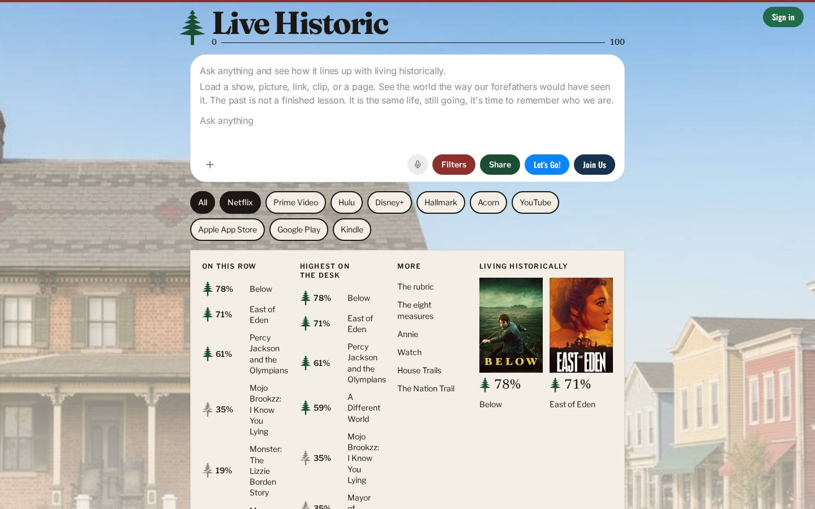
Figure 1. The desk. The pine, the range from 0 to 100, the search, and the evening already forming.

The door
Open the desk and the first nine doors are what a house needs: Your house, the Nation Trail, the Rubric, the Measures, the House Trail, the Kitchen, the Commons, Annie, and the Homestead. The rail continues, because a house that is ready will want the rest: the commonplace, the shelf, the guild, a month to forward, tickets, desk hours, the old songs, the shop, the terms, and the desk in a pocket. The door is how a newcomer stops being lost. If the door fails, the strategy is a speech.
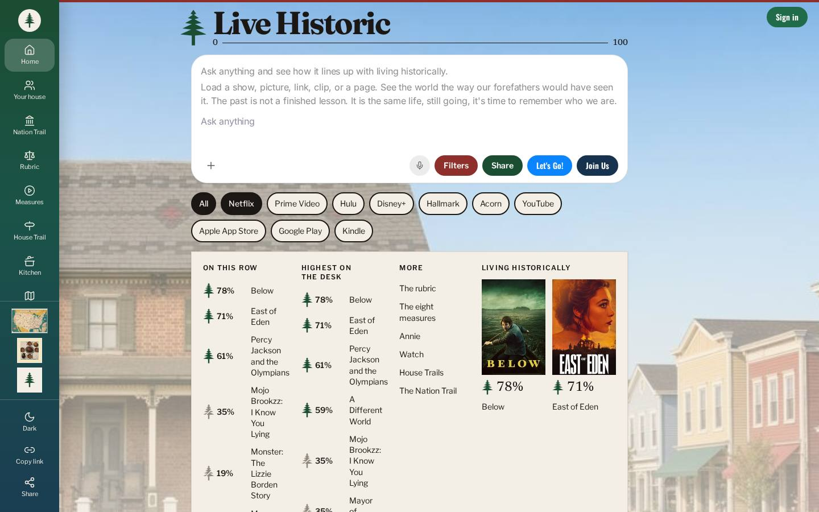
Figure 2. The door open. Navigation is a house, not a sitemap.

Your house
Your name on the door, and the family desk. A house needs a name before it can pass anything on. This is the membership the charter means: a household, not a shareholder account.
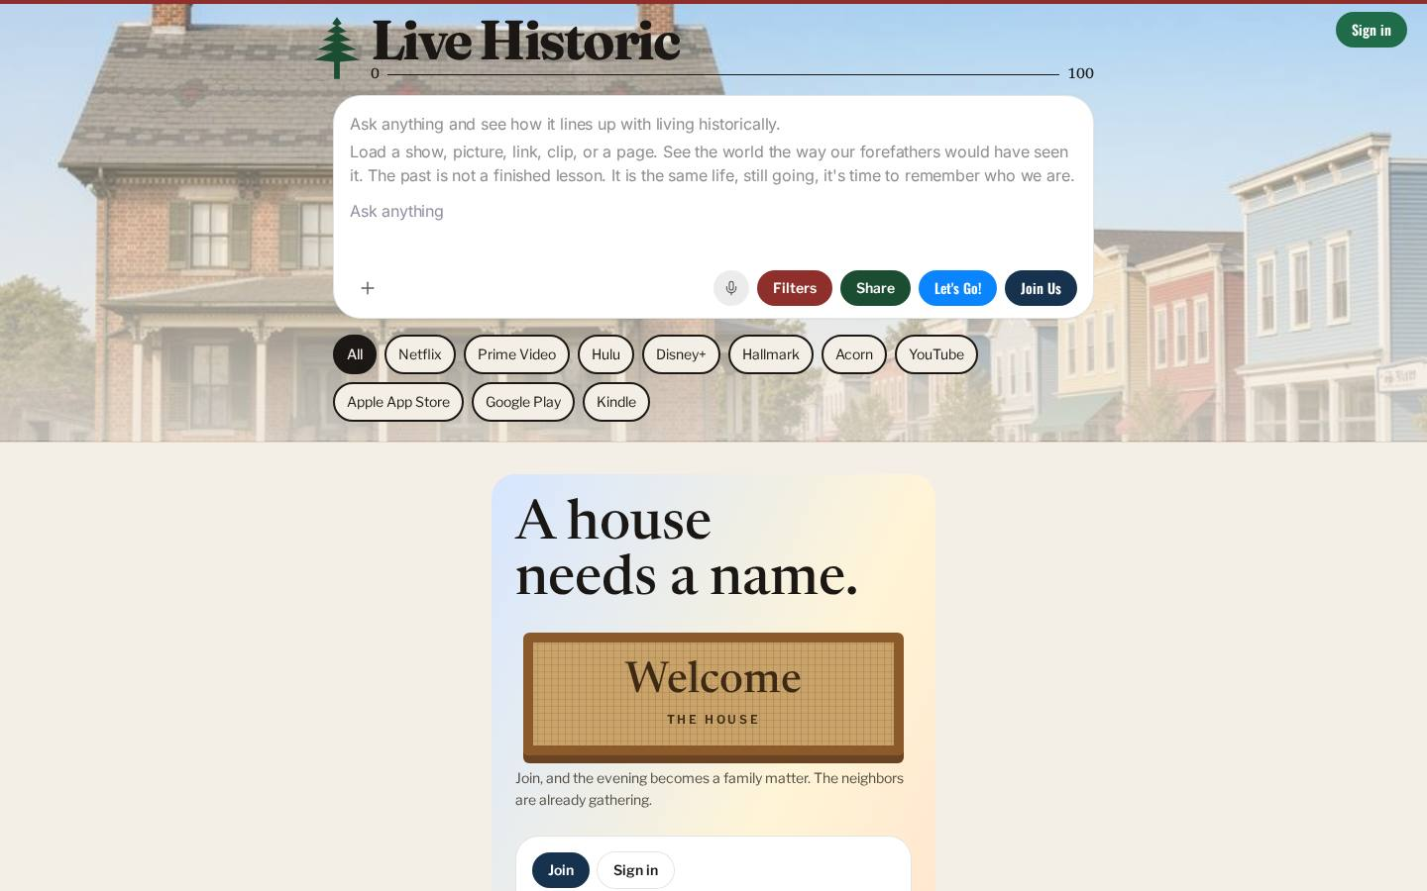
Figure 3. Your house. A name on the door.

Nation Trail
The shelves, by company and by year. Memory with a spine. This is part of the institutional memory in Part VI: not a feed, a trail a house can walk again.
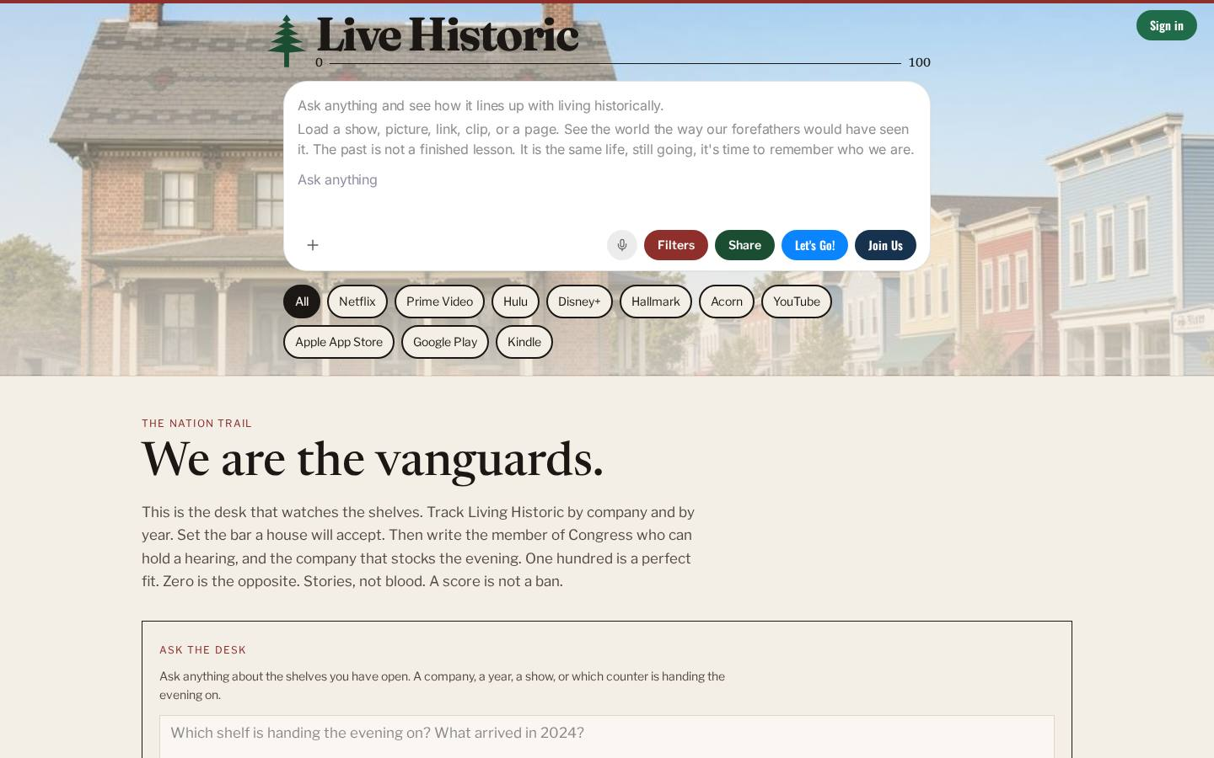
Figure 4. The Nation Trail. The shelves, kept so a year can be found again.

Rubric
The eight measures, and how a score is made. This is the values leg of the stool, written so a house can check the desk. The page also tells the truth Article III requires: the standard is not a costume, and the people of 1800 were often wrong. Authentic, in Part IV, depends on that sentence staying visible.
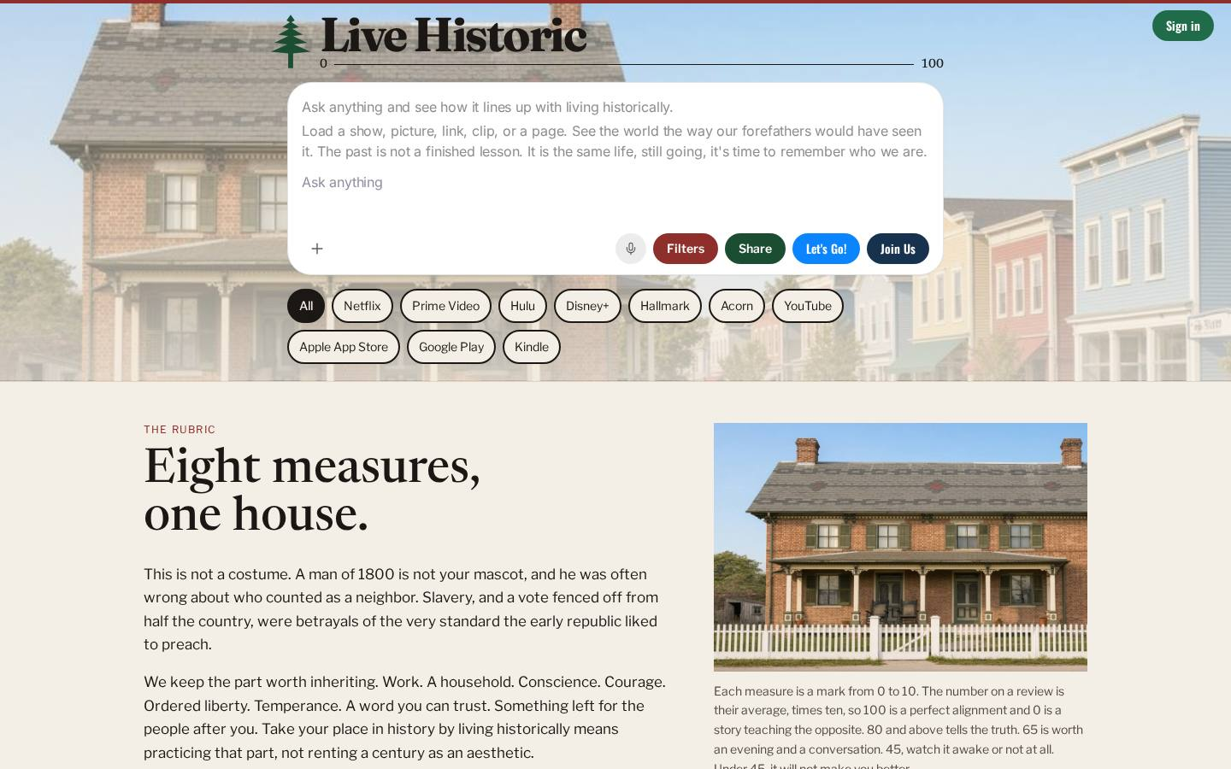
Figure 5. The rubric. Eight measures, one house, and the method on the table.

Measures
One minute of film for each measure. The values are not only a table. A house can watch the virtue before it argues about a score. The films are free.
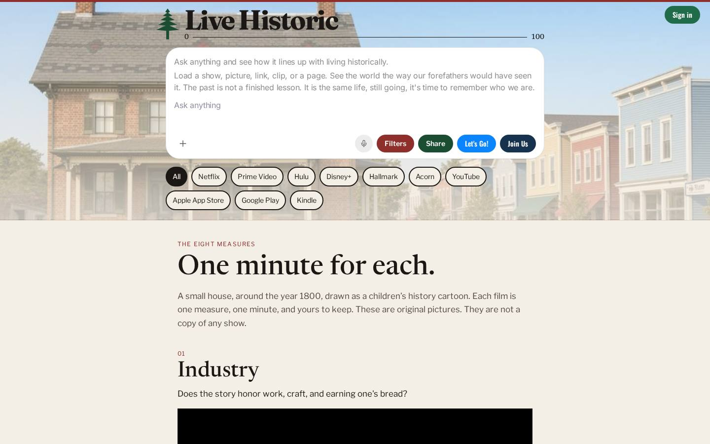
Figure 6. One minute for each measure.

House Trail
The wagon game. Do not let a bad story in. This is the sandbox: practice at stewardship of an evening, without pretending the game is the evening itself.
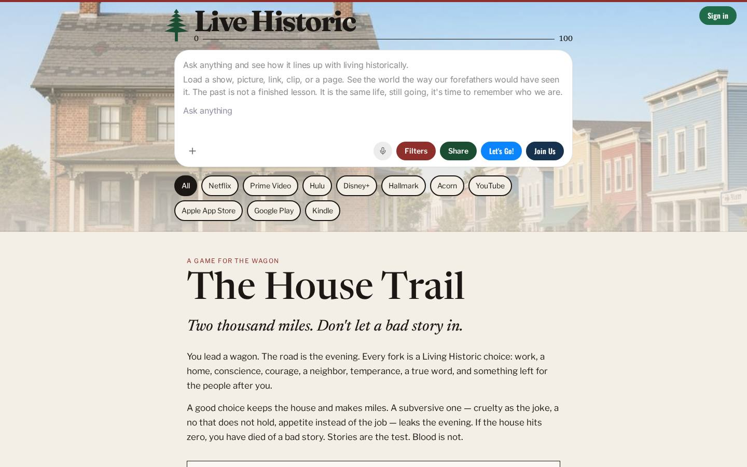
Figure 7. The House Trail. A game with the same eight, so practice does not invent a new morality.

Kitchen
What a house puts on the table. A recipe is a small stewardship: something handed on, in the hands, not in a speech. The biscuits are pictured because a room should open onto a particular thing, not only onto a menu.
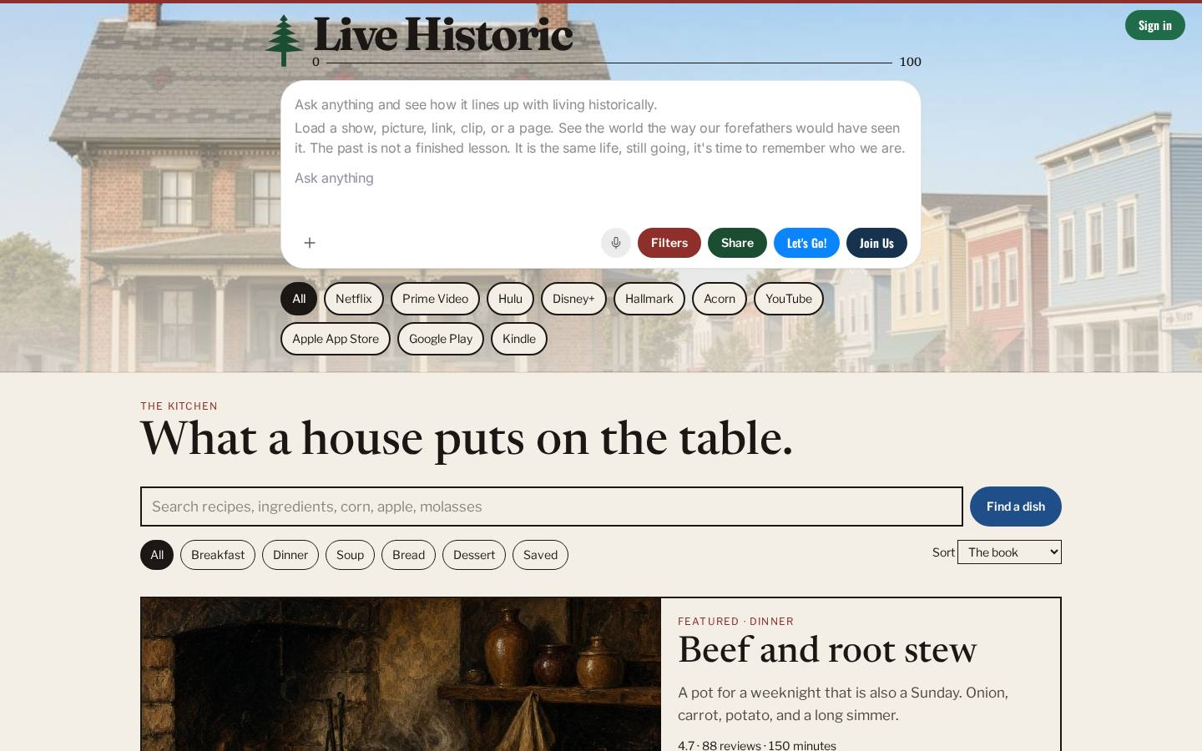
Figure 8. The kitchen. A menu of what a house puts on the table.
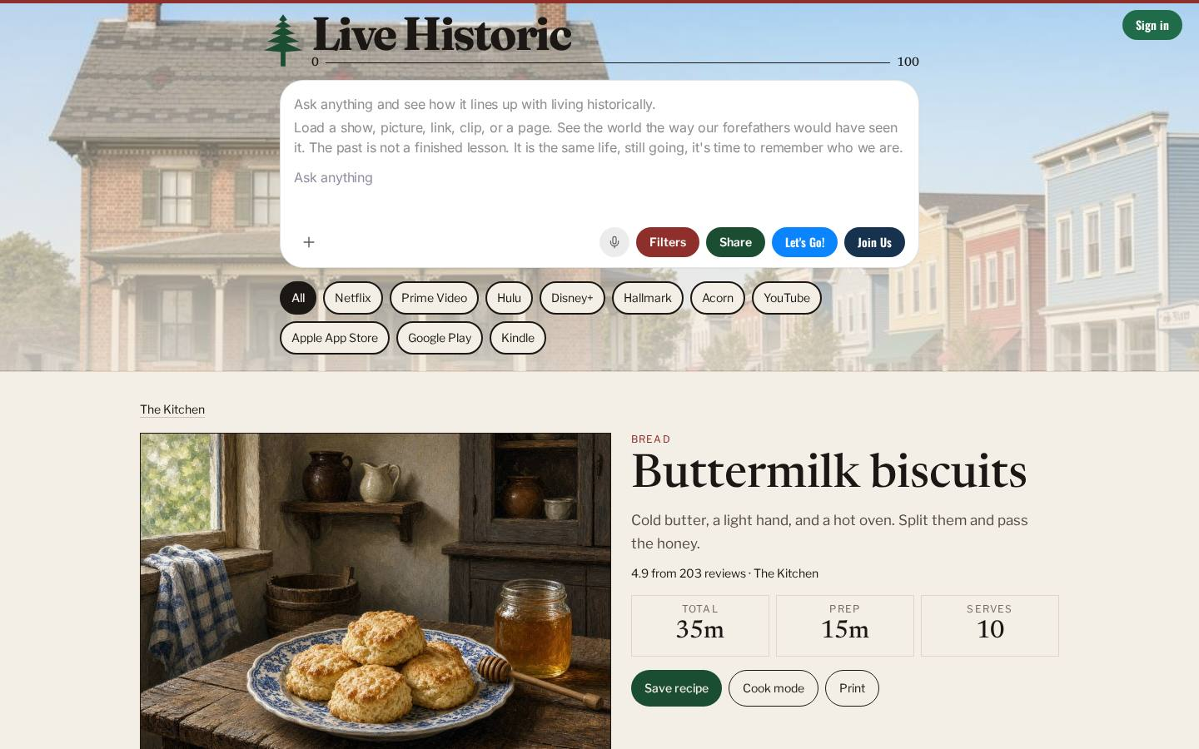
Figure 9. A single recipe, buttermilk biscuits. The particular, which is where a house actually lives.

Commons
Groups and evenings near you. The town's seat at the purpose platform. A house is not required to be lonely in order to be serious. Deeper doors open onto a group and onto an event.
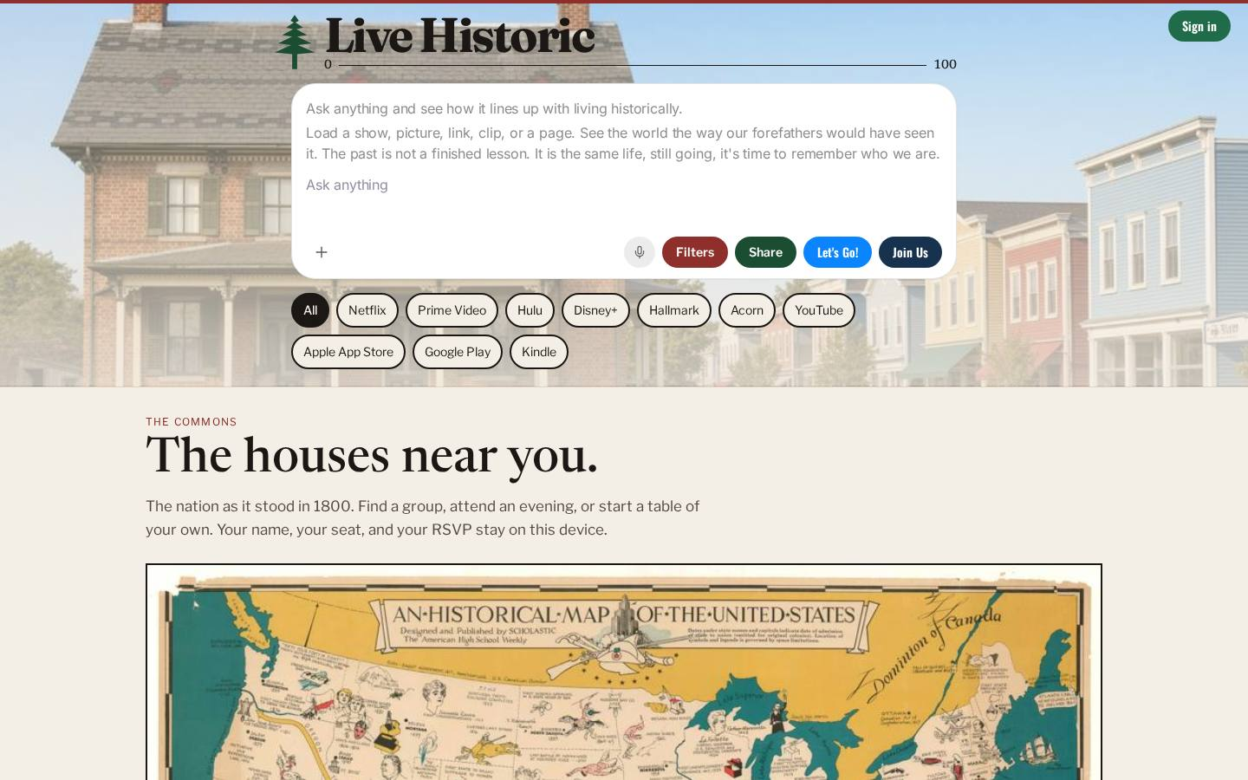
Figure 10. The commons. The houses near you.

Homestead
A family's own record of the evening. This is memory that belongs to the house. It is how “pass it on” becomes a practice instead of a motto.
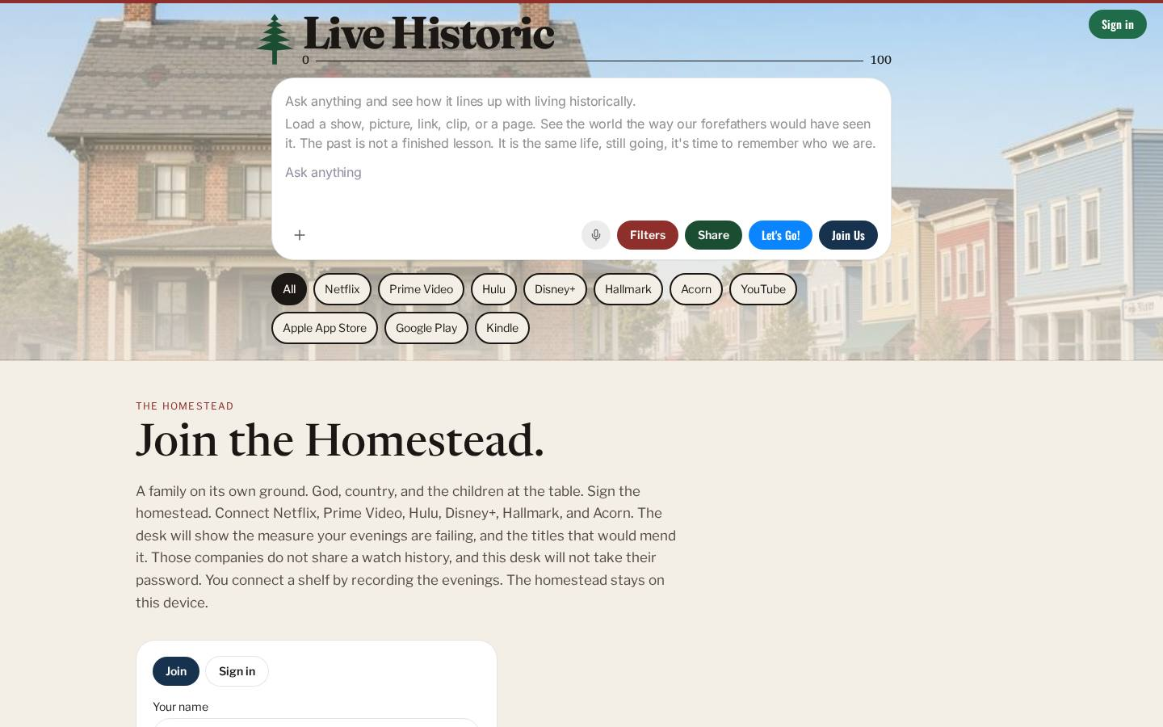
Figure 11. The homestead. The evening, written down so it can be inherited.

Annie
She scores any story, and she sings. She is a voice of the desk, not a second standard. If she ever scores against a different eight, the commitment in Part III is broken. A house may ask her. The rubric still outranks the charm.
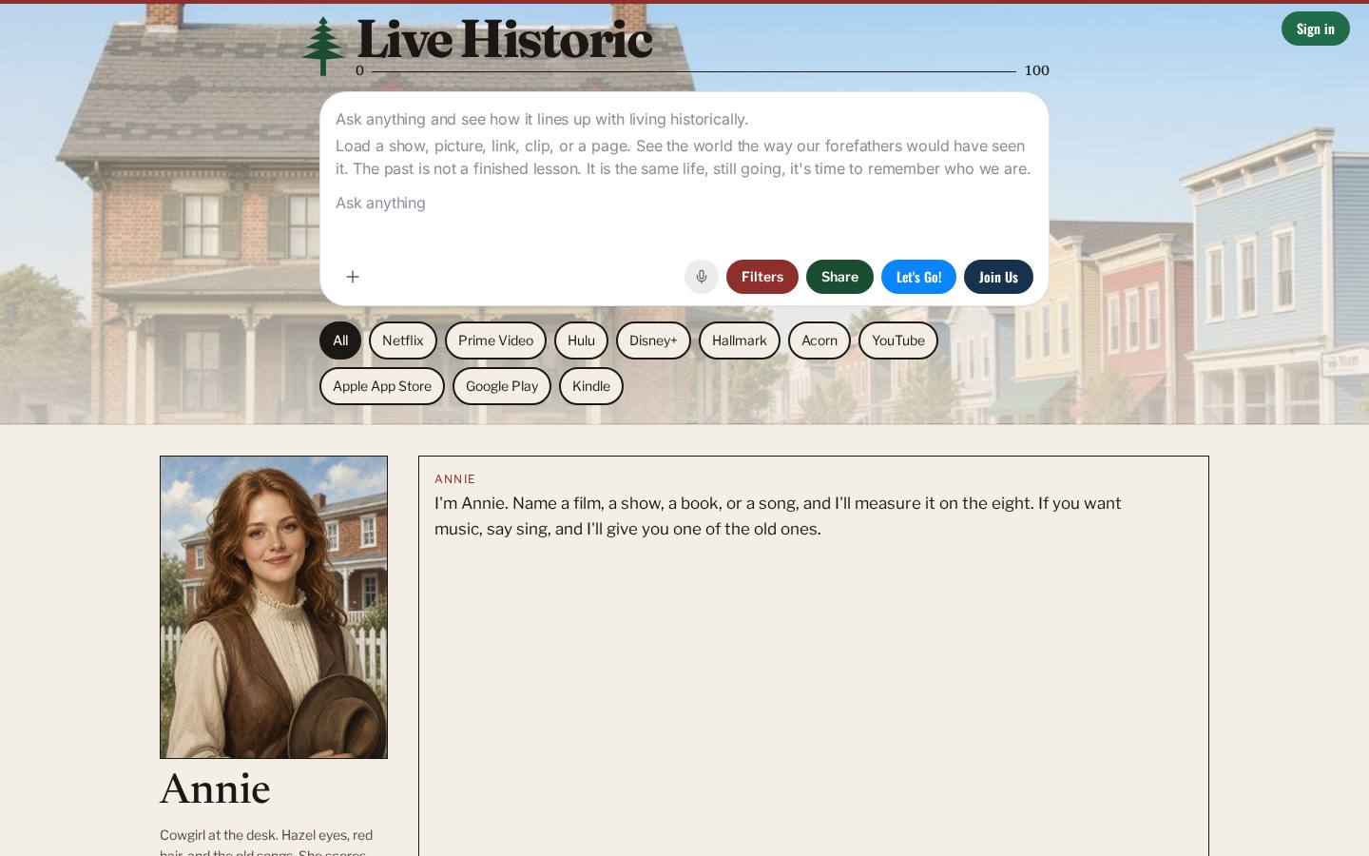
Figure 12. Annie. A voice that still answers to the eight.

Commonplace
The measures you meant to keep, stored on this device. This is the privacy promise and the memory promise in one room. Clearing the browser clears the book. That is a feature, not a loss to be “fixed” by a warehouse.
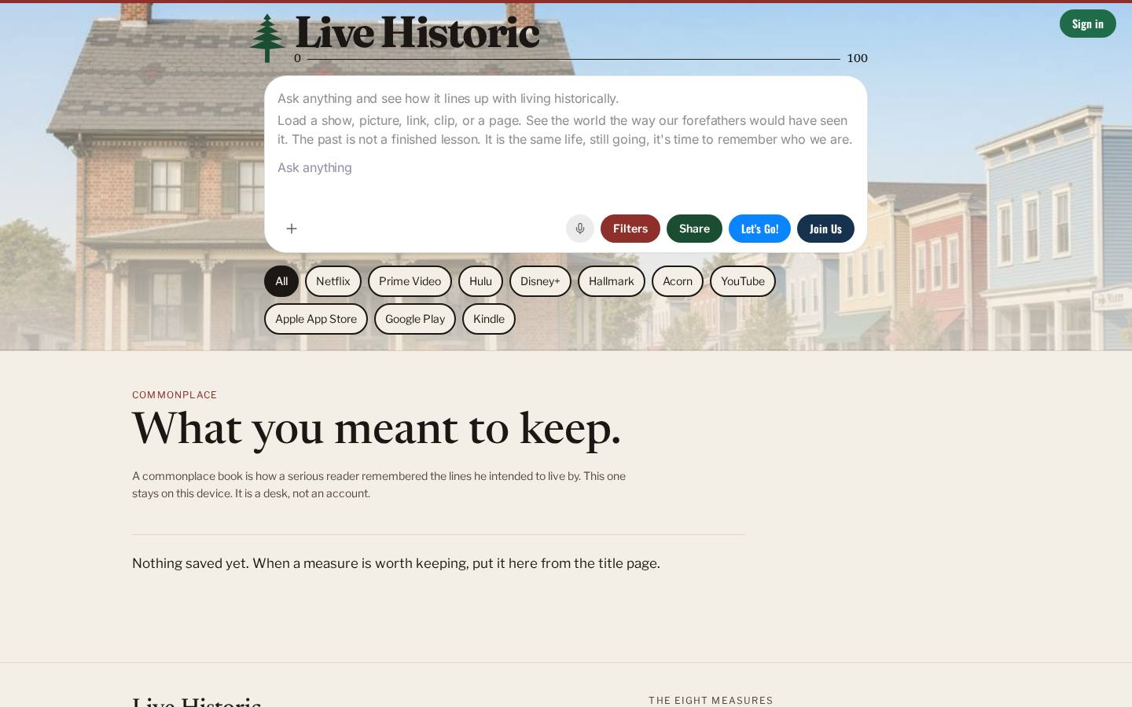
Figure 13. The commonplace. What you meant to keep, on your own device.

Watch
The free films and the scored shelf. Watch is where the measure and the thing you might actually play meet. Our own films are here. Other titles are linked, not taken.
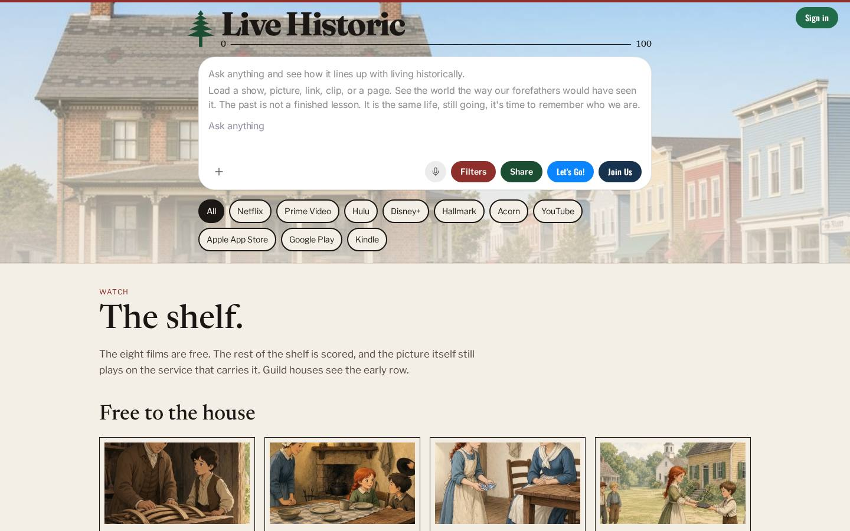
Figure 14. The shelf. Free films, and the scores beside the names.

Guild
A seat at the desk. Vote on the next story. Not a subscription to a stranger, and not a purchase of the number. The guild is how the organizational altitude stays tied to houses.
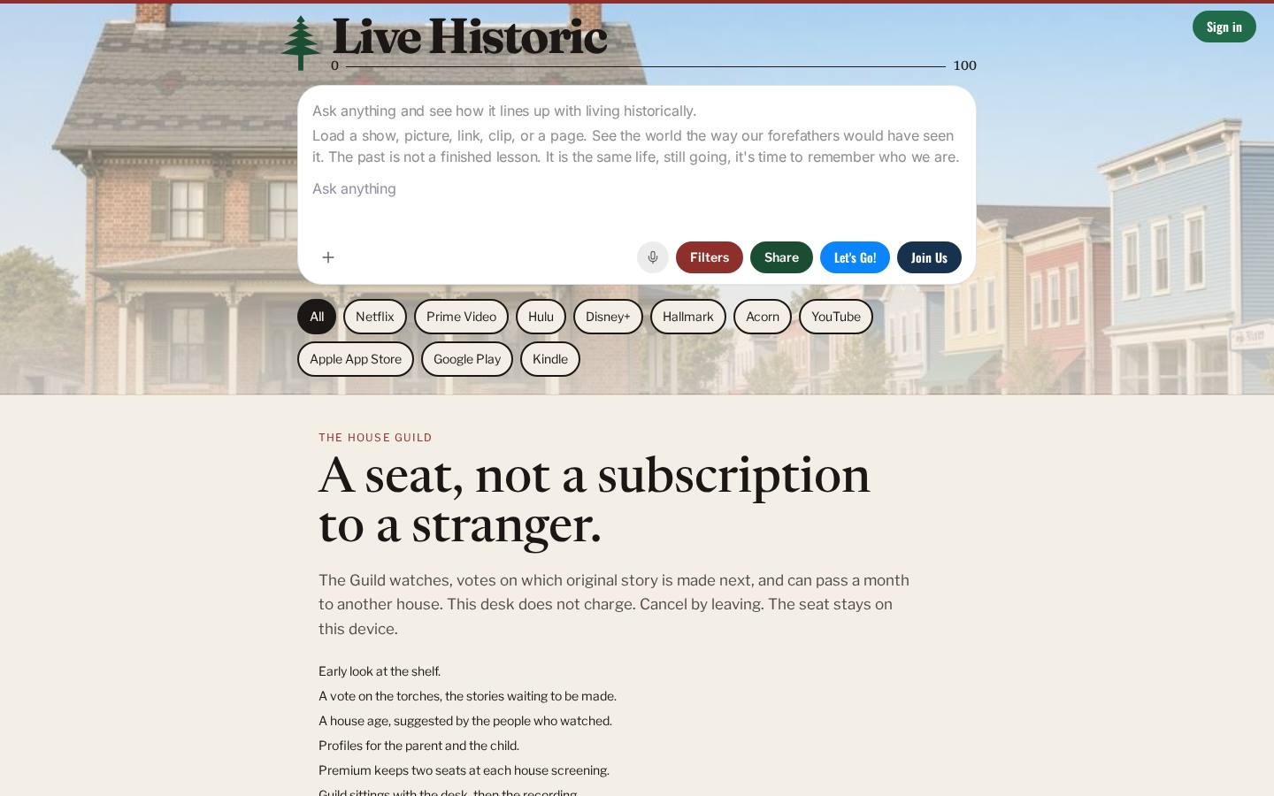
Figure 15. The guild. A seat, not a subscription.

Forward
Pass a month to a house that has not sat down yet. This is the vision, operational: pass it on. It is also a promise the steward in Part VII must not make if the reserve cannot keep it.
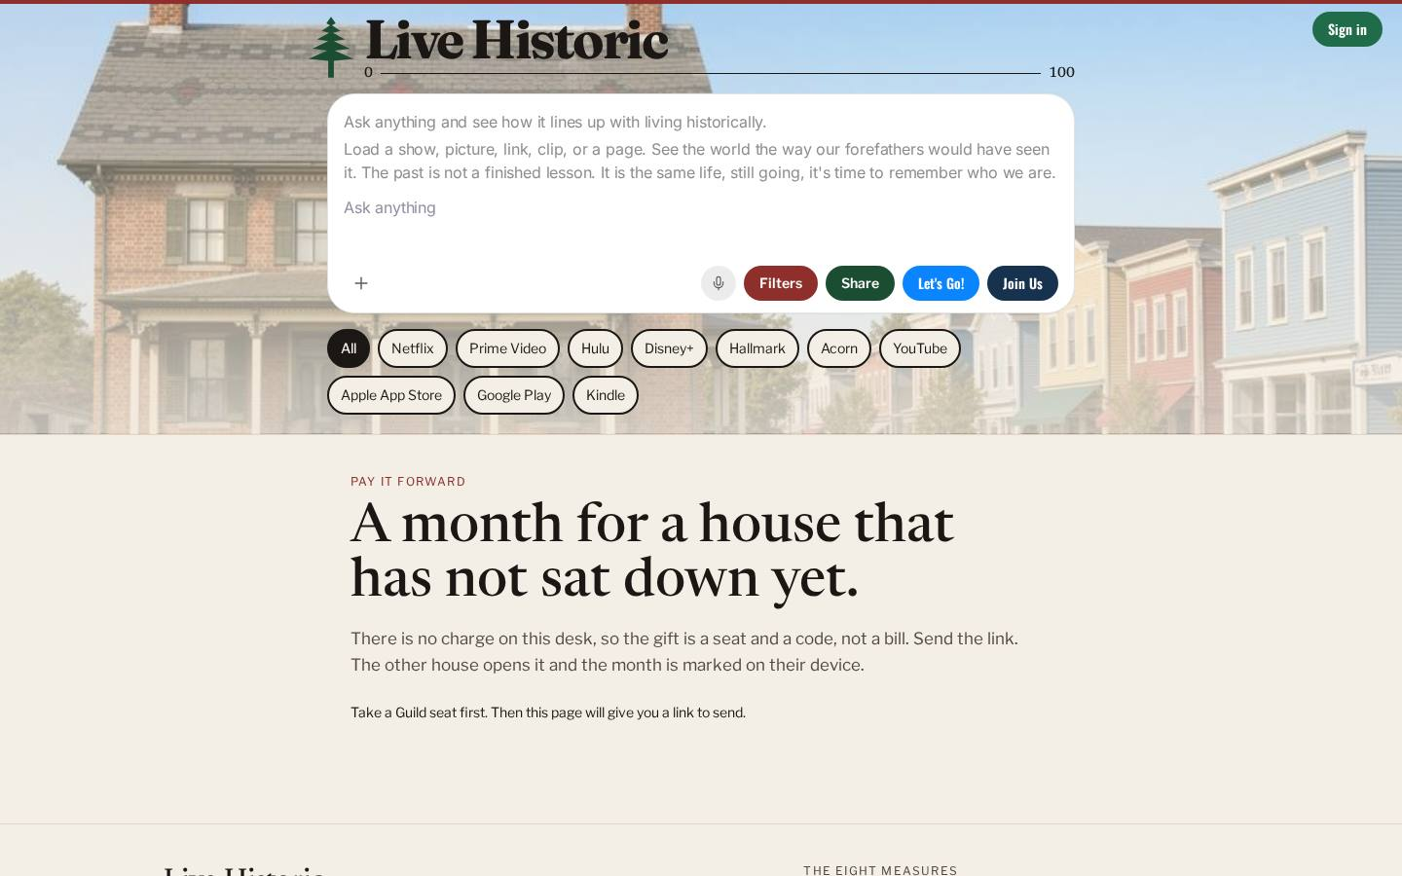
Figure 16. Forward. A month for a house that has not sat down yet.

Tickets
Reserve a seat at a house screening. The commons, made particular: a night, a room, a story chosen on purpose.
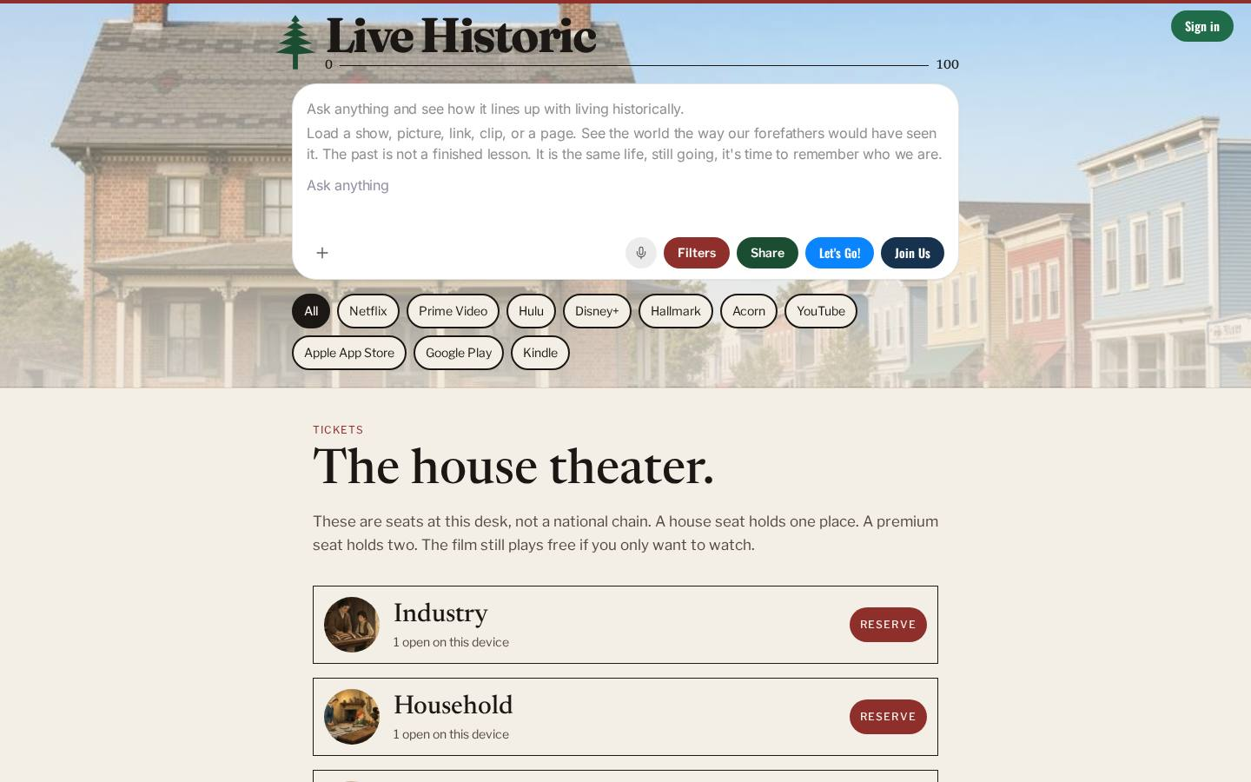
Figure 17. Tickets. The house theater.

Desk hours
The desk, when it sits. Live hours, and the recording after, so a house that could not be in the room can still hear the standard said out loud.
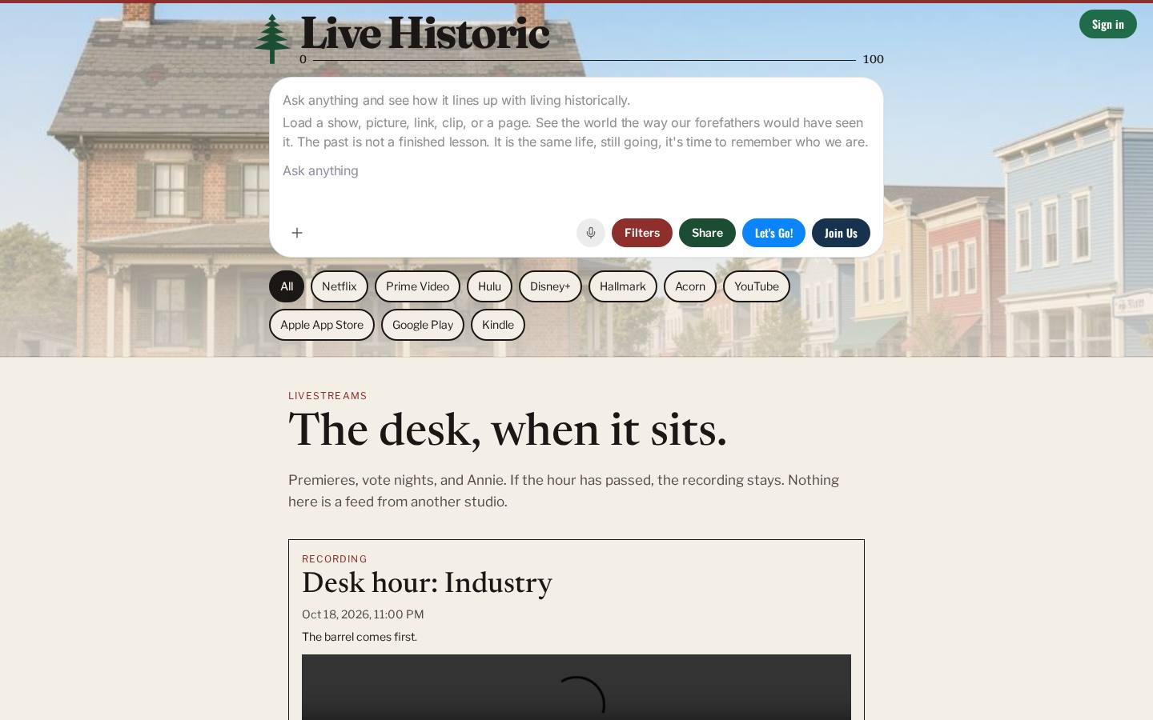
Figure 18. Desk hours. The desk, when it sits.

Music
The old public-domain songs. Inheritance you can sing. Not a catalog we licensed into a costume. The songs are old because the public has them, and a house may have them too.
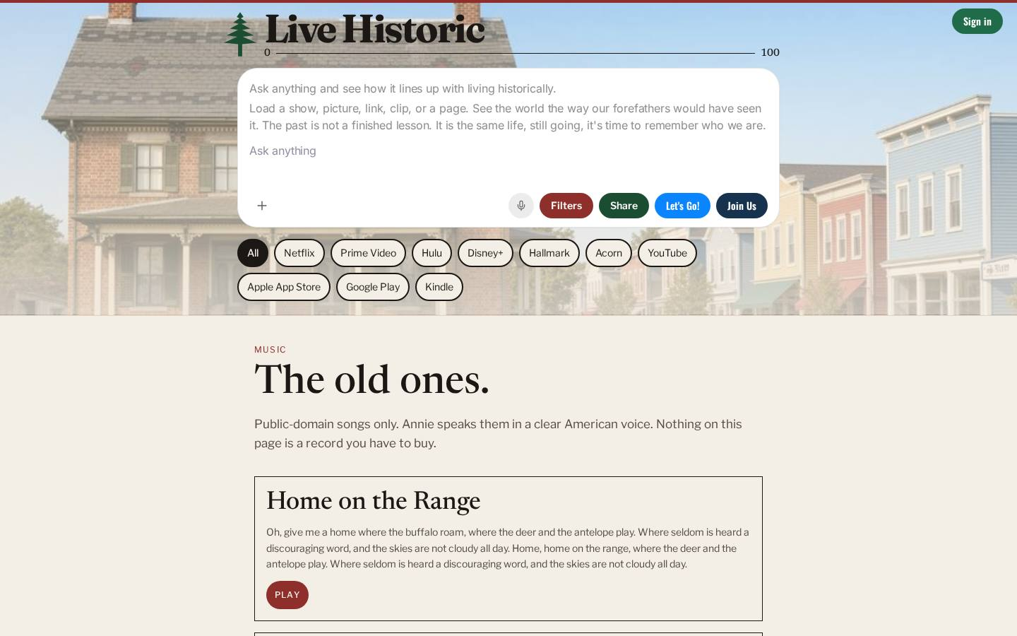
Figure 19. The old ones.

Shop
The films and the mark, yours to keep. The shop is not a second business hiding inside the charity. It hands over what the desk itself made. It is not an offer of stock. It does not sell another maker's picture. It does not sell a softer score.
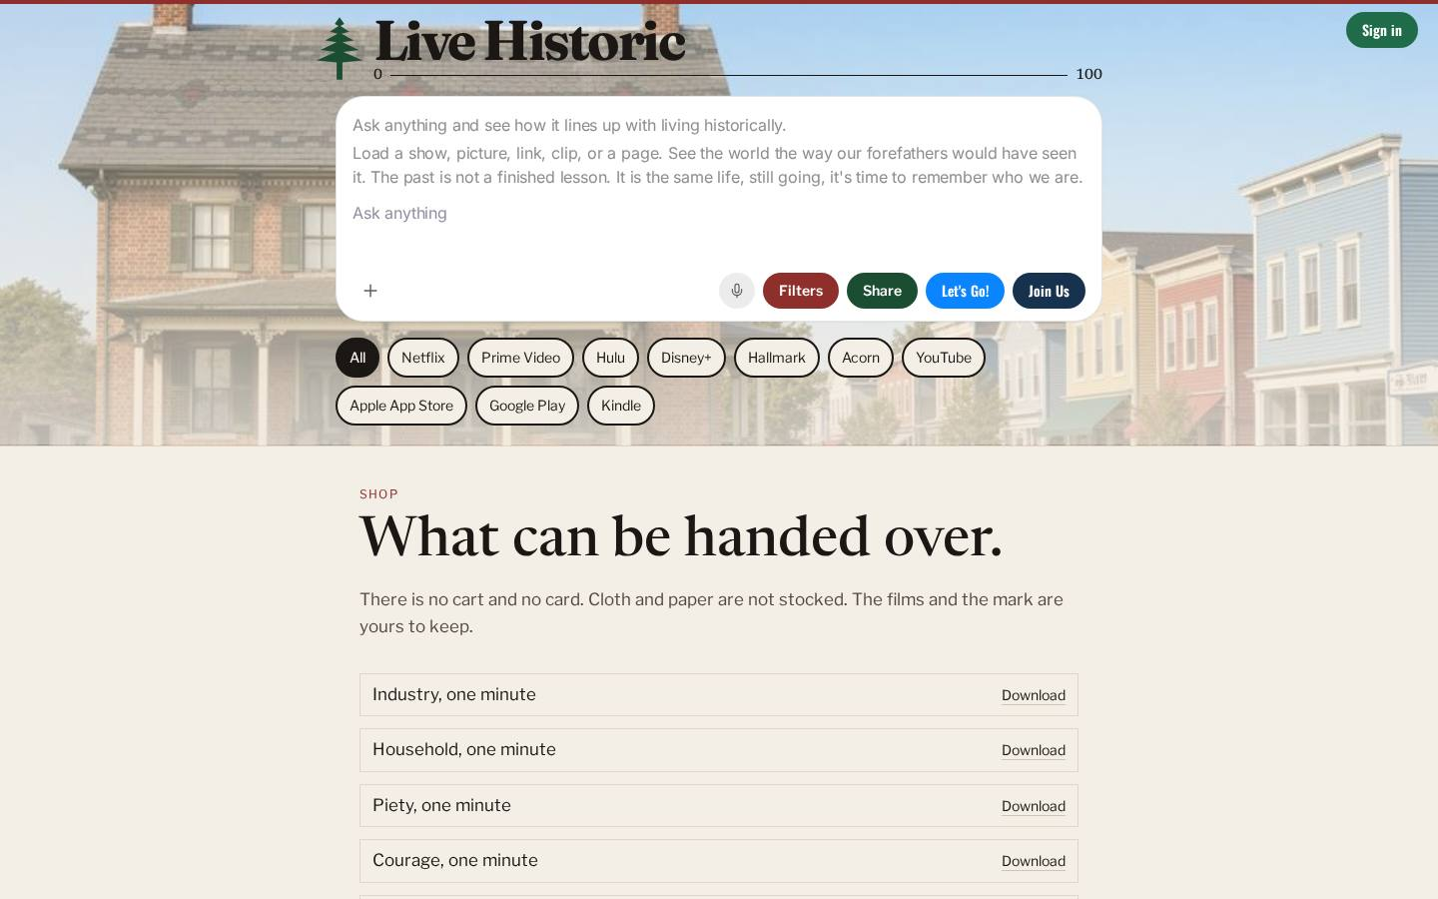
Figure 20. The shop. What can be handed over.

About
What the desk is, and the plain terms. The mission in short, how to get help, the terms (including that nothing here is an offer of stock), and the privacy of the guild and the commonplace. This charter and the short film of the rooms are linked from that page, quietly. They are papers of the house. They are not a campaign stapled over the desk.
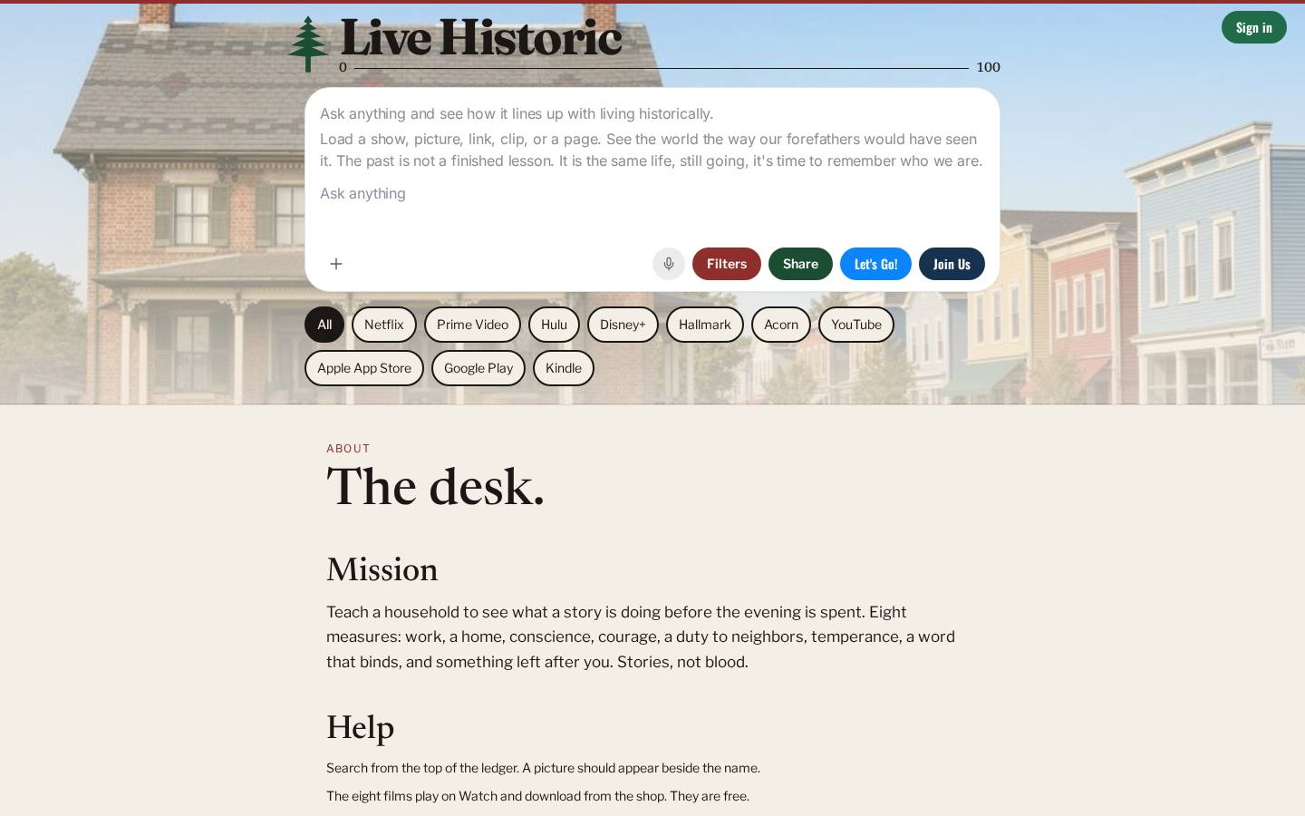
Figure 21. About. The plain terms.

Get the desk
Put Live Historic on the phone. The evening happens in the pocket now. A desk that only exists at a wide screen has abandoned the room where the feed actually is.
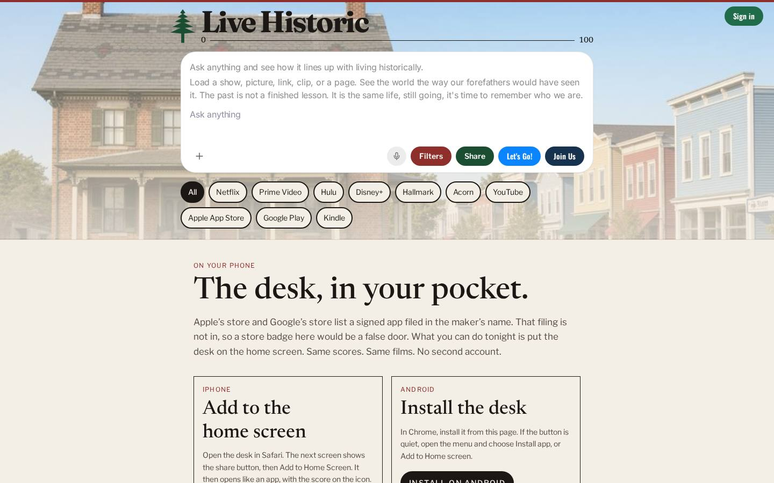
Figure 22. The desk, in your pocket.

The mark
The pine, stated on its own page, so a house can see the mark without the rest of the furniture. A separate pictures page holds the public images of the mark for a house that wants them in its own hands. The mark is not a person. The mark is not a coat of arms borrowed from a century.
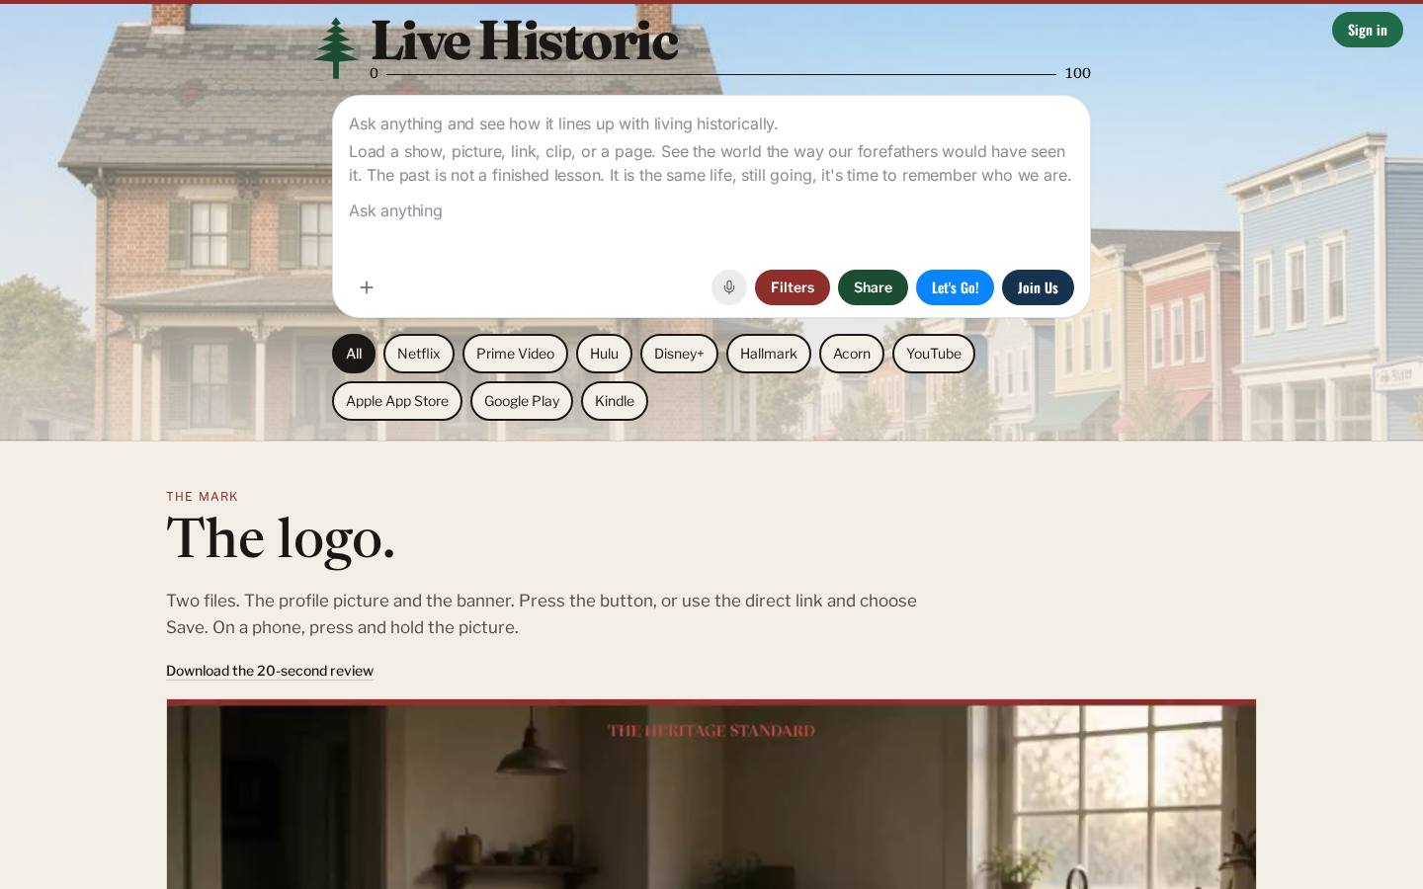
Figure 23. The mark. A pine, and the words.

How a house actually moves
From | To | Why it is one desk
Home, a name on the ledger | The title's review | The number beside the name opens into the eight marks. Same arithmetic.
Any room | The door | No room is a dead end. The rail is the same list everywhere.
Rubric | Measures | Read the virtue, then watch a minute of it.
Kitchen | A recipe | The menu opens onto the particular dish.
Commons | A group, an event | The town opens onto a night.
Watch or the ledger | Share | A measure that is not handed on is still a private opinion.
Guild | The next story | Houses help choose the work. They do not buy the mark.
Forward | Another house | The vision, as a deed.
About | This charter, and the film | The long reason, available, not shouted.

The full rail, in the order a house meets it: Home. Your house. Nation Trail. Rubric. Measures. House Trail. Kitchen. Commons. Homestead. Annie. Commonplace. Watch. Guild. Forward. Tickets. Desk hours. Music. Shop. About. Get the desk. Off that rail: a title, a recipe, a group, an event, the mark, and the pictures of the mark.

Part IX — The revolution, and the ask
The feed taught a house that the next thing is the real thing, and that a private taste is the same as a judgment. It is not. A household is raised by a standard the whole house can see, argue with, and hand to the people who are not here yet. That is the revolution. It does not seize a catalog. It does not found a party. It puts a measure on the table and refuses to sell the hour it just saved.
What we are really trying to accomplish, said one last time: a household that can see what a story is doing before the evening is spent, and that can pass that sight on.
What we must do, said one last time: keep the measure free. Keep the eight the same in every room. Put the number back in the house. Do not sell attention.
Join us. Live Historic. Plant trees under whose shade you will never sit. This is a revolution. A private opinion does not raise a household.

Adoption
The houses then sitting may adopt this charter by signing below. Until they do, these lines are blank, and the charter is offered, not imposed. No person is named here as founder, chair, or mark. The purpose leads.
Adopted this ________ day of ________________________, 20________.
 | House | Name of the person signing for the house | Signature
1
2
3
4
5
6

By adopting, a house affirms Articles I through X, including the refusal to sell the measure, the refusal to score blood or party, the dissolution to a similar public charity, and the duty to say plainly that an IRS determination is a filing and not a fact already in hand.

Part X — Appendix

How to read the number
Each measure is an integer from 0 to 10. Add the eight marks. Divide by eight. Multiply by ten. Round to the nearest whole number. That is the score. A 10 on every measure is 100. A 0 on every measure is 0. A house that wants the long reason reads the marks. A house in a hurry may say the seal.
Score | Seal on the desk | Band | Note
80–100 | Living Historically | It tells the truth | Sit with it.
65–79 | Worth an evening | Worth an evening | Then have the conversation.
45–64 | Watch awake | Watch it awake | Or don't watch it.
0–44 | Leave it | Leave it | It will not make you better.

On the rubric page the same bands are said in the house's language: 80 and above tells the truth; 65 is worth an evening and a conversation; 45 is watch it awake or not at all; under 45 will not make you better. The two wordings are the same bands. They are repeated so a card and a conversation do not drift apart.

The eight, in the desk's words
This is the scoring key as the desk itself states it. The charter does not paraphrase the values into softer nouns. A scorer who will not use these sentences is not using this desk.

Industry
Does the story honor work, craft, and earning one's bread?
Franklin's point was never the hustle poster. It was that a free man feeds his house by being useful, and that leisure is sweet only after the work.
High. Work is honored, and a person is more useful at the end than at the start.
Low. Getting is cut loose from making. Ordinary work is a joke, or a windfall is the moral.
What it is not. Not a sermon about hustle, and not a wage. A poor man who does his work can outscore a rich man who does not.

Household
Are marriage, fidelity, and children treated as a life, or as a prop?
Around 1800 the home was the first government. A story that shrugs at vows, or uses a child as furniture, has already left the standard.
High. Marriage, parents, and children are a life the story takes seriously.
Low. The home is furniture, a prison, or a laugh. A child is used and not protected.
What it is not. Not a demand that every story be about a family. A story with no house can still honor one, or show what the absence costs.

Piety
Is conscience real here, or is reverence only a costume?
Washington's Farewell called religion and morality indispensable supports. We are not scoring denomination. We are asking whether the soul is allowed to be a fact.
High. A soul is allowed to be real, and a person can be bound by it.
Low. Reverence exists only to be exposed, or the story has no room for conscience at all.
What it is not. Not a denomination test. Quiet about church is not a failure. A cross in the shot is not a pass.

Courage
Does anyone risk something that matters, or is it only noise?
Swagger is cheap. Courage costs a reputation, a fortune, a body, or a friendship. Moral bravery outranks a fistfight.
High. Someone pays a real price, for a reason that is not only himself.
Low. Noise, revenge dressed up as bravery, or a hero who risks nothing he cares about.
What it is not. Not a preference for violence. A fistfight can be cowardice. A quiet refusal can be the brave act.

Republic
Does anyone owe a neighbor, a law, or a town — or is every man a predator?
Ordered liberty. Self-government. A cynicism that insists everyone is only a grifter fails this, even when the cynicism is stylish.
High. A person belongs to a people, and duty is not the punchline.
Low. Every man is a predator, every office a grift, and the story enjoys the conclusion.
What it is not. Not a party score and not a pageant. A story can criticize a town and still believe a duty is owed to one.

Temperance
Is appetite put in its place, or is the viewer trained to want more of it?
Drink, lust, rage, luxury, the endless feed. A story may depict excess. It fails when it catechizes you into it.
High. Excess may appear, and it is not the teacher.
Low. The pleasure of the story is the loss of the limit. The viewer is trained to want the next one.
What it is not. Depicting a vice is not the same as teaching it. A hangover with a bill can outscore a glamorous binge.

Truth
Does a word still bind, and does deceit come with a bill?
A man's name was a kind of currency. Stories that make the lie the whole glamour, with no reckoning, cheapen the currency.
High. A promise costs something, and deceit is not the costume the story loves best.
Low. The lie is the whole charm, and nobody pays.
What it is not. Not a ban on surprise. A twist is fine. A life built on deceit, and rewarded for it, is not.

Stewardship
What is left for the people after you — a place, a craft, a name?
Posterity was the quiet American religion: land kept, a trade taught, a town not stripped. If the story has no future tense, it is already poor.
High. Someone keeps a thing they will not live to finish enjoying.
Low. The story ends in the self. Nothing is owed to the people who come after.
What it is not. Not only land, and not only money. A skill taught, a house kept, a name left clean: those count.

A short glossary
Word | Meaning on this desk
House | The people who share an evening and mean to pass something on. The member. Not a shareholder.
Desk | The whole instrument: rubric, rooms, and the number. Not a brand sitting on top of a different business.
Measure / score | The 0–100 figure. An opinion of a story under the eight. Not a ban. Not a state rating.
Seal | The word that travels with the number: Living Historically, Worth an evening, Watch awake, Leave it.
The feed | The arrangement that spends the evening before the house has seen what the story is doing.
Gift | Support that keeps the door open. It does not buy a mark.
Reserve | Months of hosting, held so a thin month does not close the door.
Guild | A seat from which a house votes on the next story. Not an ownership of the number.
Commonplace | What a house meant to keep, stored on its own device.
Annie | A voice that can score and sing, and that does not get her own eight.

Source note
The frameworks in Parts II through VII come from materials of the CUES Advanced Management Program and eCornell, 2026, used here as tools and answered in full: Professor Chekitan S. Dev, Brand Purpose (“People Don't Lead People, Purpose Leads People”), including the iceberg, the three-legged stool, the eight characteristics of brand purpose, the added characteristic “commitable,” the mind-body-spirit mapping, and the purpose-platform pattern; Professor Dev's Five BRAND Pillars, scored 1 to 5 against the pillar descriptions and not against rival brands; General (Retired) George Casey, Leading in a VUCA World (July 2026), including Murray's three principles, the note to self, the sand pile, the four VUCA definitions with their impacts and actions, BE and DO, the offensive mindset, the operating environment, the two questions, the rule of sustaining oneself, the leadership altitudes, and the Najaf loop; Brad Treat, COO Mindset: Leading Growth Through Change and Operational Shifts, including the dual altitude, variation and the critical few, DMAIC, the traits of a useful metric, sandboxes, quality planning, and institutional memory; Professor Drew Pascarella, CFO Mindset: Connecting the Numbers to Strategy and Performance (August 26, 2026), including how a credit union meets its cost, the balance sheet as the business, capital and liquidity, and the questions of what to do and how to help.
Applying a tool is not an endorsement. Nothing in this charter speaks for those faculty, for Cornell, for the SC Johnson College of Business, for eCornell, or for CUES. Credit-union percentages, capital ratios, and industry charts discussed in the CFO session are not reproduced as if they were the books of Live Historic. This desk has no audited financial statements in this paper. Hilton's purpose platform and the Zappos and Hilton value lists are comparison cases from the brand session. They are not our values and not our claim of their sponsorship.
The eight measures in this appendix are the desk's own scoring key. The rooms in Part VIII are the desk as it stood when this charter was drawn. If a room changes, the charter's test does not: the same eight, the measure free, the number back in the house, nothing sold.
Join us. Live Historic.

